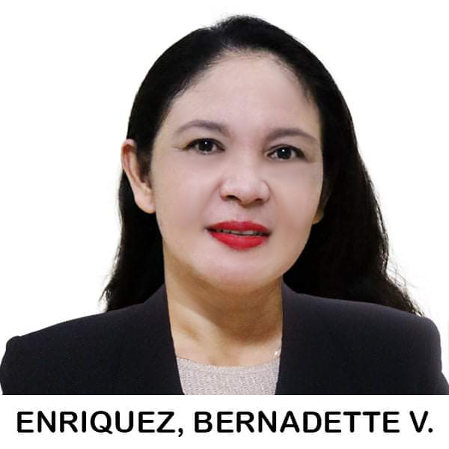
Enriquez, Bernadette Vizconde
Address: 522 Diliman 1st San Rafael, Bulacan 3008
Cellphone No. : 09612947172
Email Address: badethenriquez6@gmail.com

Personal Information
Date of Birth: April 18, 1976
Age: 45
Nickname: Badeth
Mother: Ma. Concepcion M. Vizconde
Father: Conrado V. Vizconde
Religion: Roman Catholic
Place of Birth: San Rafael, Bulacan
Position Desired: Registered Midwife
Gender: Female
Occupation: Business Woman

Educational Attainment

Tertiary Education
School: Mary Chiles College
Degree: Midwifery
Address: 667 Gastambide Street Sampaloc, Manila
School Year: 1993 - 1995

Secondary Education
School: Maginao-Cruz na Daan High School
Address: Maginao San Rafael, Bulacan
School Year: 1989 - 1993

Primary Education
School: Diliman Elementary School
Address: Diliman 1st San Rafael, Bulacan
School Year: 1983 - 1989

Work Experience

Position: STAFF MIDWIFE
Year: March 3, 1997 – February 15, 2007
Hospital: Capitol Medical Center (Tertiary Hospital)
Address: Scout Magbanua Corner Panay Avenue Quezon City
Area: OB/Gyne Ward, Medical Surgical Ward and Pediatric Ward

