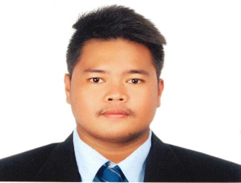
RENZ PAULO H. MARASIGAN
Blk 6 San Jose, Tarlac City
Contact No: 0909451175145/09294416821
Email: renzpaulomarasigan26@gmail.com

QUALIFICATION:

- Positive attitude, and hard working with the ability to adapt the environment very easily
- Good communication
- Flexible and fast learner
- Willing to work on different shifts
- Can work efficiently even under pressure
- Responsible
- Trustworthy

OBJECTIVE:

Looking for job and opportunity where I can practice,
Develop, and share my abilities, knowledge, skills and experience specifically in
the course of Information Technology and other related fields.

PERSONAL INFORMATIONS:

Age : 22y/o
Date of Birth : December 24, 1998
Civil Status : Single
Gender : Male
Citizenship : Filipino
Religion : Roman Catholic
Height : 5’11
Weight : 98
Language/Dialects : Taglish

EDUCATIONAL BACKGROUND:

Tertiary : Tarlac State University - College of Computer
Studies
San Isidro Campus, Tarlac City
Bachelor of Science in Information Technology
2015 (Present)
Secondary : San Manuel High School (SMHS)2011-2015
Elementary : San Jose Elementary School (SAES)2005-2011
SEMINAR EXPERINCE:

- CCNA Cisco Seminar
    - 2015
    - Tarlac State University - College of Computer Studies Engineering Building
    - San Vicente, Tarlac City

- ICTD Seminar Series 4
    - 2017
    - Tarlac State University - College of Computer Studies AVR
    - San Isidro, Tarlac City

- How to Survive BPO
    - 2018
    - Tarlac State University - College of Computer Studies AVR
    - San Isidro, Tarlac City

- Information Security
    - 2018
    - Tarlac State University - College of Computer Studies AVR
    - San Isidro, Tarlac City
- Internet of Things
    - 2018
    - Tarlac State University - College of Computer Studies AVR
    - San Isidro, Tarlac City

SKILLS:

- Computer Trouble Shooting
- Microsoft Office (Ms. Word, Power point, Ms Excel)
- Ability to work as individual or as part of a team

I hereby certify that the above information is true and correct to the best
of my knowledge and belief.

Applicant’s Signature

