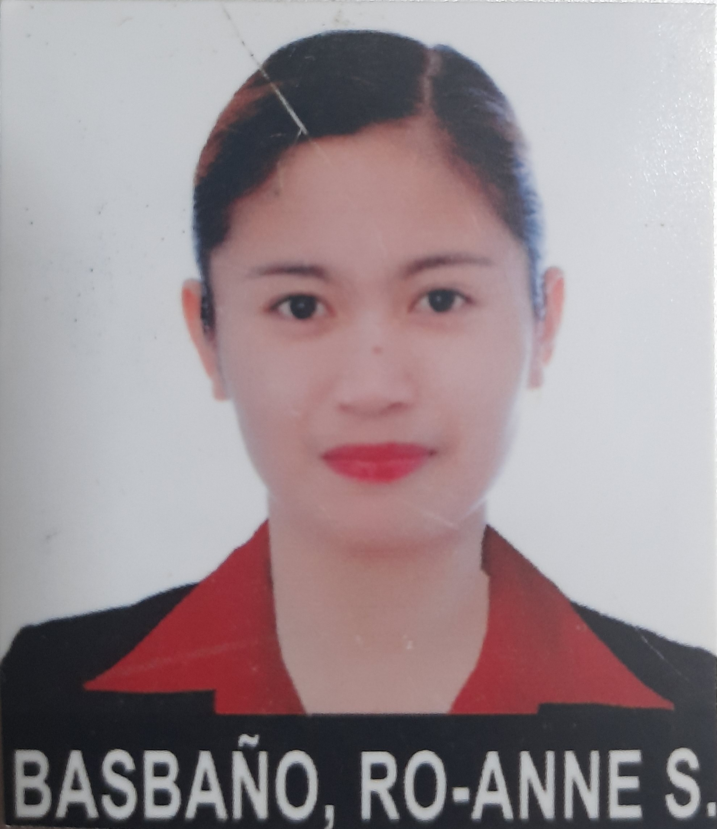

Ro-anne S. Basbano
Cell : (63) 945-591-3198
Address: Brgy. Jalaud Sur, Zarraga, Iloilo, Philippines
Email : roannebasbano@gmail.com

Professional Summary
A graduate of Bachelor of Science in Nursing, a Licensed Nurse and currently working as a Police Officer at Philippine National Police and designated as Police/Nurse Vaccinator.

Skills
- Good Communication Skills - Care
- Computer Literate - Commitment
- Adaptable - Empathy
- Flexible - Passion

Experience
Police Officer 1 – February 2017 to Current
Regional Medical and Dental Unit 6, Cam Martin Teofilo Delgado, Fort San Pedro, Iloilo City, Philippines

Education
University of Iloilo – 2008 to 2011
Bachelor of Science in Nursing
Rizal St., Iloilo City Proper, Iloilo City, 5000 Philippines

Personal Information
- A Filipino Citizen, 31 years of age, married, with 2 kids and willing to be an Immigrant in your country together with my family.
Seminar and Workshop
Licensed Nurse – 2013 to Present
American Safety and Health Institute Basic Life Support
Basic IV Therapy Training Program

Reference
Anne Rose P. Precia
Patrolwoman
Philippine National Police / Camp Martin Teofilo B. Delgado, Fort San Pedro, Iloilo City
(63) 928-4925-496

