 | 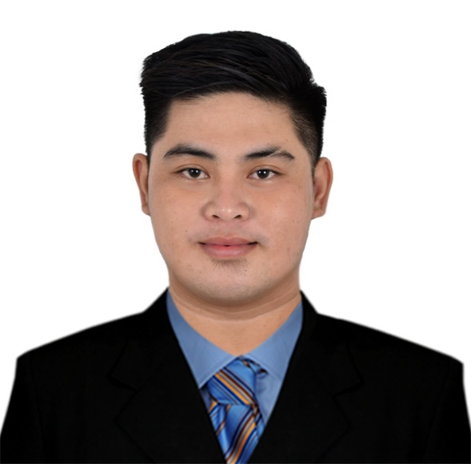 |  | Ralph Gian b. monje  work experience  Radio Mindanao Network Inc., Dagupan City, Pangasinan (240 hours. on-the-job training)  05/2017-06/2017  - As Assistant Radio Technician, I am responsible for maintenance, checking and repair of radio equipment.  Asticom Technology Inc. – Globe Telecom  01/2020-09/2020  Service Provisioning Officer  - Provision cabinet/line port profile in U2000 and other NMS head station  - Validate profile should be with ISA line profile format  - Identify correct/eligible accounts and pre-qualified accounts prior profile change  - Assist with system and application installation or software configuration as needed.  09/2020-PRESENT  Broadband Support Engineer (Technical Support)  - Assist in monitoring all JOs from dispatch and completion.  - Coordinates with internal and external support teams in line with the completion of JOs.  - Assists in cancellation of ageing JOs from Sales Partners.  - Dispatches JOs and sends report to SLI Contractor and Field Operations.  - Answers installation and repair follow up from different groups.  - Updating of work orders in the system.  - Coordinate with customer of new appointment schedule.  - Conducts verification of restoration done.  EDUCATION  Colegio de Dagupan  06-2014 – 04-2019  Bachelor of Science in Computer Engineering  Santo Thomas Catholic School  06-2009 – 04-2013  Poblacion, Mangaldan Pangasinan  SEMINARS  BASIC OCCUPATIONAL SAFETY AND HEALTH (BOSH)  Lite Review Center, Arellano St., Dagupan City (05/2017)  FIVE S and SOLAR ENERGY  AVT Colegio de Dagupan (02/2018)  CONSTRUCTION OCCUPATIONAL SAFETY AND HEALTH (COSH)  YMCA, Tapuac District, Dagupan City (07/2018)  LOSS CONTROL MANAGEMENT (LCM)  YMCA, Tapuac District, Dagupan City (02/2019)  Skills & Abilities  - Computer Literate: MS Word, MS PowerPoint, MS Excel, Download and Upload data (Image, Audio, Video, File,etc.) AutoCad 2011  - Strong work ethic needed for success in any career.  - Excellent verbal and personal communication skills.  - Accuracy and Attention to details.  - Excellent organization and prioritization skills.  - Excellent verbal and personal communication skills.  - Knowledgeable in Google Sheets, Google Forms

OBJECTIVE
Extremely motivated and passionate in whatever I choose to do. Strong Interpersonal and communication skills and know to handle and deal with different kinds of people and circumstances. Equally effective working independently and in cooperation with others.

vITALS
#237 Bari Mangaldan, Pangasinan
Cell. No: +639126708242
Email address: monjeralph24@gmail.com

Date of Birth: December 21, 1996
Place of Birth: Dagupan City, Pangasinan
Civil Status: Single

REFERENCEs
ENGR. JESSON ANTON
INSTRUCTOR
Colegio de Dagupan
09463234623/09951191230

ENGR. RODERICK CABAÑA
ASSISTANT DEAN
Colegio de Dagupan
09074114173

ENGR. ROMULO ROEL PINLAC
INSTRUCTOR
Colegio de Dagupan
09177697363

I do hereby declare that the above information is true to the best of my knowledge.

Ralph Gian B. Monje

