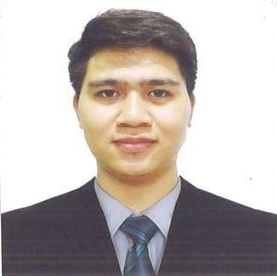
QUILANG, JAYCEE L.
Pangilinan St., New Lower Bicutan, Taguig City
0929 482 4455
jayceequilang123456789@gmail.com

WORK EXPERIENCE

Security Personnel
Sep 2020-Apr 2021
SMARTGUARD SECURITY SERVICES, INC.
Makati City, Philippines

Security Personnel
Apr 2021-Jan 2022
ACHIEVERS SECURITY AGENCY PHILIPPINES
Makati City, Philippines

Security Personnel
Jan 2022-Present
AMCOR SECURITY & INVESTIGATION AGENCY, INC.
Mandaluyong City, Philippines

OBJECTIVE
To work in a challenging environment, where I can utilize my skills as a criminology graduate and engage with the team of experts that will improve my capabilities as an efficient and effective individual.

EDUCATION
Bachelor of Science in Criminology
Taguig City University
Taguig City, 2015-2020

Gadu National High School
Cagayan Valley
2010-2014

Villa Salud Elementary School
Cagayan Valley
2004-2010

PERSONAL INFORMATION

Age: 24 Gender: Male
Date of Birth: January 5, 1998 Civil Status: Single
Place of Birth: Solana, Cagayan Valley Religion: Christian
Nationality: Filipino

SKILLS AND QUALIFICATIONS

Language and Level: Proficient in English and Tagalog
Computer Skills: Oriented in Microsoft Word, Microsoft Excel, Microsoft Power Point

CHARACTER REFERENCE

Laidy Nairie Mangonday
Special Investigator/Prosecutor Inspection,
Monitoring and Investigation Service
National Police Commission
09183978018
Quezon City

I hereby certify that the above information is true and correct to the best of my knowledge and belief.

