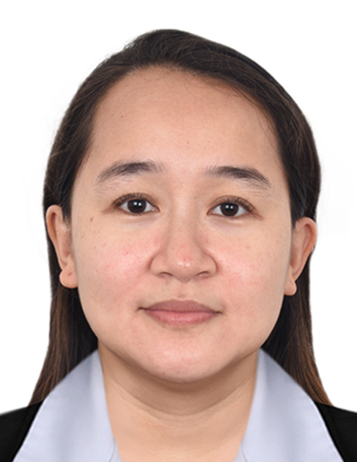
MARIA ISIDRA TAN PELAYO
Unit 2114-S, Rivergreen Residence, Pedro Gil Street, Brgy. 880, Santa Ana,
1009 Manila, NCR, Philippines
E-mail: mariaisidrapelayo@yahoo.com
Contact # +63 927 297 8715 _______________________________________

Objectives:
To obtain a responsible and challenging job and opportunity where I could practice my knowledge and develop my personality as a career person while utilizing my skills to bring out the best of my potentials. To be able to apply and continue the work experiences and gained knowledge.

Personal Information:
- Age : 35 years old
- Birthday : May 24, 1986
- Sex : Female
- Religion : Iglesia Filipina Independiente (Aglipayan)
- Civil Status : Married
- Height : 5’0”
- Weight : 60 kilos
- Nationality : Filipino
- Language Spoken : English, Tagalog
- Father’s Name : Danilo Tan Sr.
- Mother’s Name : Alma E. Tan

Skills and Qualifications

- Fast learner and very much willing to accept new challenges
- Dedicated and hardworking individual
- Highly organized and efficient
- Ability to work independently or as a part of a team
- Ability to work with or without supervision
- Capable to work well in a high-pressure work environment.
- Outstanding communication and listening skills.

Technical Skills:

- Microsoft Office (MS Word, MS Excel, Power Point, etc.)

Educational Attainment:
Tertiary:
Associate in Health Science Education
Colegio San Agustin-Bacolod
Benigno S. Aquino Drive, 6100 Bacolod City, Negros Occidental
S.Y 2004 -2006
Secondary:
Northern Antique Vocational School (NAVS)
Brgy. Poblacion, Culasi, 5708 Antique
S.Y 1999- 2003
Primary:
Esperanza Elementary School
Brgy. Esperanza, Culasi, 5708 Antique
S.Y 2002 – 2008

Working Experience:

- Concentrix Philippines
SM Mega mall, PHL, 8th to 11th
Floors, Mega C Building EDSA corner
Dona Julia Vargas Avenue
Mandaluyong City, PHL, Philippines, 1550
Position: Advisor I, Customer Service – Financial Account
April 29, 2021 – July 5, 2021

- Processing the payments and withdrawals of customers by phone.
- Ensuring customer queries are answered to their satisfaction.
- Handling customer complaints or handling them to a supervisor.
- Providing information about products and services.
- Dealing with online, email and telephone queries.
- Updating customer’s personal information.

- Key Cash & Paylite Lending, Incorporated
1706 Angel Linao St., Brgy. 686, Paco, Manila, Philippines
Position: Accounting Staff / Cashier
June 29, 2009 – March 16, 2020

- Entering financial information into appropriate software programs
- Managing company ledgers
- Processing business expenses
- Verifying bank deposits
- Managing day to day transactions
- Assisting the finance department and senior accounting staff members with various tasks, including preparing budgets, records, and statements
- Posting daily receipts
- Managing payroll

- Jollibee Foods Corporation
Gaisano City Mall – Bacolod City
Position: Cashier & Service crew
August, 2007 – April, 2008

- Take orders from customers for food or beverages
- Serve food or beverages to customers
- Collect customer’s payment
- Invite them to comeback

Character References:

Aiza G. Isada
Keycash & Paylite Lending, Inc
Corporate Secretary
Contact no. +63 939 005 3524

Zyrine Valerie Nalaunan Suante
Concentrix Philippines
Reporting Manager
SM Mega all, PHL, 8th to 11th
Floors, Mega C Building EDSA corner
Dona Julia Vargas Avenue
Mandaluyong City, PHL, Philippines, 1550
Contact nos. +63 930 356 0174
+63 (02) 423-8700 loc 354428

I hereby certify the above information is true and correct in the best of my knowledge and belief.

Maria Isidra Tan Pelayo
Applicant’s Signature

