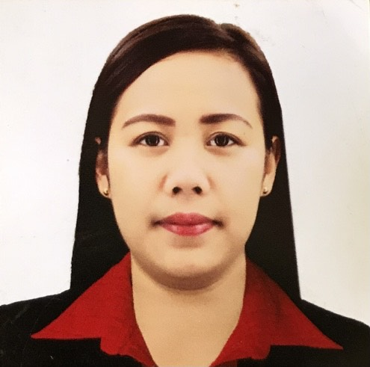
MARIA JESUSA R. SAMSON
Address: Barangay Cabitnongan San Nicolas Pangasinan
Contact Number: 09108272662
Email Address: mariajesusasamson25@gmail.com

OBJECTIVE
To obtain a position that would best fit my qualification and develop further my talents and skills for continuous career development.
SKILLS
- Able to speak English
- Able to follow instructions
- Computer Literate(Microsoft Office ,PowerPoint ,Web Browsing)
- Basic Nihonggo Language
PERSONAL INFORMATION
Name: Maria Jesusa R. Samson
Age: 25
Birthday: December 25, 1995
Provincial Address:Cabitnongan San Nicolas Pangasinan
Status: Single

EDUCATIONAL BACKGROUND
- Tertiary Education
June 2012-May 2017
Bachelor of Science in Tourism Management
University of Baguio, Baguio City

- Secondary Education
June 2008-April 2012
Red Arrow High School
Magsaysay Street San Nicolas, Pangasinan

- Primary Education
June 2001-2008 Cabitnongan Elementary School San Nicolas, Pangasinan
ON THE JOB TRAININGS
Company: 2go Vessel St. Francis Xavier
Location: Ermita, Manila Philippines
Position: Front desk, Housekeeping, Food& Beverage

Company : Apple bees grill and bar
Location: Dickinson North Dakota, United states of America
Position: Line Cook,Prep and Receptionist

Company: Astoria Hotel
Location: AklanBoracay, Philippines
Position: Front Office and Food& Beverage

SEMINARS and TRAININGS
Cargo handling course -2017and 2018
Cargo Acceptance and Rates-2017
Mia Seminar-2017 and 2019
Contel Seminar-2017-2018
Dangerous Goods Awareness-2017
Airside Safety/Human Factors-2017
Safety Management System-2017

JOB EXPERINCE
CARGO SERVICE AGENT - Macro Asia Airport Services c/o Philippine Airlines(2017-2020)
LINE COOK&PREP- Applebees Grill and Bar(2016-2017)

AWARDS AND ACHIEVEMENTS
November 15, 2014 Certificate of Recognition1st Northern Luzon Tourism Convention Centennial Hall, University of Baguio
March 20, 2016 Ultimate Pantry Showdown Kitchen Manager award University Of Baguio.
April 01, 2017& April 20,2017 Certificate of recognition for having International onthe Job Training awardedin USA at BCC
CHARACTER REFERENCES

Norman Escalante 09177041690
Philippine airlines Import Supervisor

Victor Malapitan 09081360568
Philippine Airline Import Supervisor

Guillermo Maglaya Jr. 09276601258
Philippine Airlines
Import Warehouse Administrator

I hereby certify that information above is true to the best of my knowledge & belief.

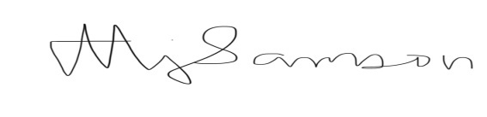

MARIA JESUSA ROSENDO SAMSON
Applicant’s Signature

