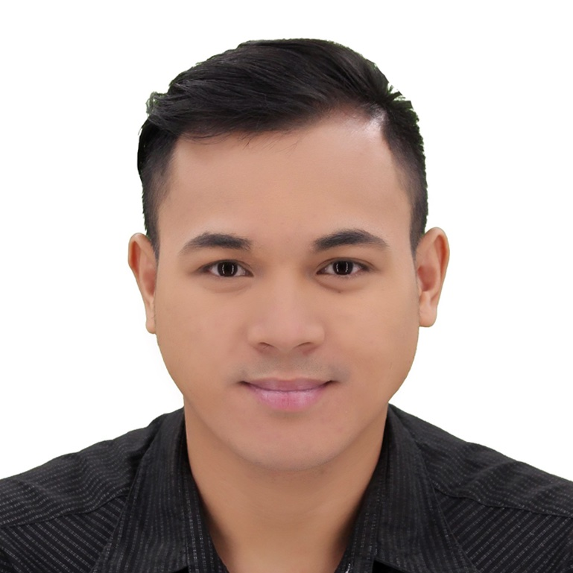
RAFFY A. RUSIANA
#3599 Barangay Street P-6 Lower Bicutan Taguig City Philippines
Contact # +639154604260
Email: raffyrusiana51@gmail.com

Objectives:

Devoted live-in Caregiver who isexcited with me prospect of new challenges hopes for an oppurtunity to employ valuable skills to embrace the life standard of the elderly.

Educational Background

MJ Padua CareGiving School
Personal Health Worker CARE-GIVING
Maharlika Taguig City Philippines
April 05 2121 To October 08 2021

Tertiary:
Informatics Institute College
Sm Bicutan Branch
June2008-April 2010

Secondary:
Signal Village National
Signal Village National taguig city
June2004- April 2008

Primary:
Silangan Elementary School
Upper Bicutan Taguig City
June 1999- March 2004

Trainings and Seminars Attended:

CareGiving National Certificate II
Technical Education And Skills Development Authority
Paete Laguna
Crtificate awarded on Decemeber 2021

Basic Intravenous Insertion Training
MJ Padua School
Maharlika Taguig City
Certificate award On October 10th 2021

Basic Nursing Skills Training
MJ Padua School
Maharlika Taguig city
Certificate Awarded On October 10th 2021

Massage Therapist Training
Technical Education And Skills Development Authority
Awarded On October 20th 2021
Work Experience:

HMO Health Insurance Lacson And Lacson
Hospitals Medical Records
Alabang City Philippines
Februay 2020 To Present

Job decription:
- Check The Diagnosis Of Patient
- Update the medical records
- Verifying the coverage of health card
- Assits the patient

Care Giving
Taguig City Philppines
August 2016 to November 2019

Job decription:
- Helping Patients prescribed medication
- Assiting Patients with personal care and hygiene
- Help patients with physical theraphy exercises
- Plan and prepare meals with assistance from the patients
- House Keeping

Raffy A. Rusiana
Applicant Signature

