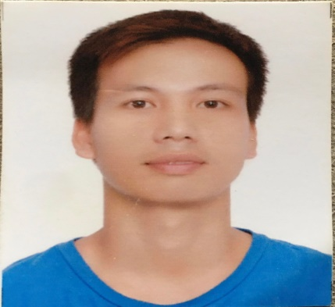
MANANSALA, RONALD VILLEGAS
357 BRGY. CANSINALA APALIT PAMPANGA
CONTACT #: 09651134607

PERSONAL INFORMATION_______________________________________________________________
Date of birth: July 22 1986
Age : 35 years old
Sex: Male
Place of Birth: Apalit, Pampanga
Civil Status: Married
Religion: Roman Catholic
Height: 5’7
Weight: 65 kg
Languages Spoken: Filipino,English,Korean
EDUCATIONAL ATTAINMENT_____________________________________________________________
Educational Level: College Graduate
School /University: AMA COMPUTER COLLEGE
Year Graduated: 2008
TRAININGS ATTENDED__________________________________________________________________
Training Title: Korean Language Course
Conducted By: Jong Phil Language Center Inc.
Duration ( hours): 80 hours
Training Title: Pre-Employment Training for the
Korean Employment Permit System

Conducted By: POEA
Duration: 38 Hours Korean Language
7 Hours Korean Culture
WORK EXPERIENCED______________________________________________________________
Position / Occupation: Machine Operator
Company Name: MYEUNG-SUNG (415-875) GYEONGGI – DO GIMPO-SI
WOLGOT-MYEON
Company Address: GIMPO-DAERO (2659) BEOM-GIL 32
Date of Employment: April 18 2015 to Feb 06 2019
Employment Type: Overseas

Position / Occupation: Machine Operator
Company Name: JUNWHO SANEOP
Company Address: Geoje Si A Ju Dong 1590 South Korea
Industry / Classification: Manufacturing of Electrical Machinery and Apparatus
Date of Employment: May 05 2011 to April 26 2014
Employment Type: Overseas

I hereby certify that all above information are true and correct to the best of my knowledge.

_____________________________
Applicant’s Signature

