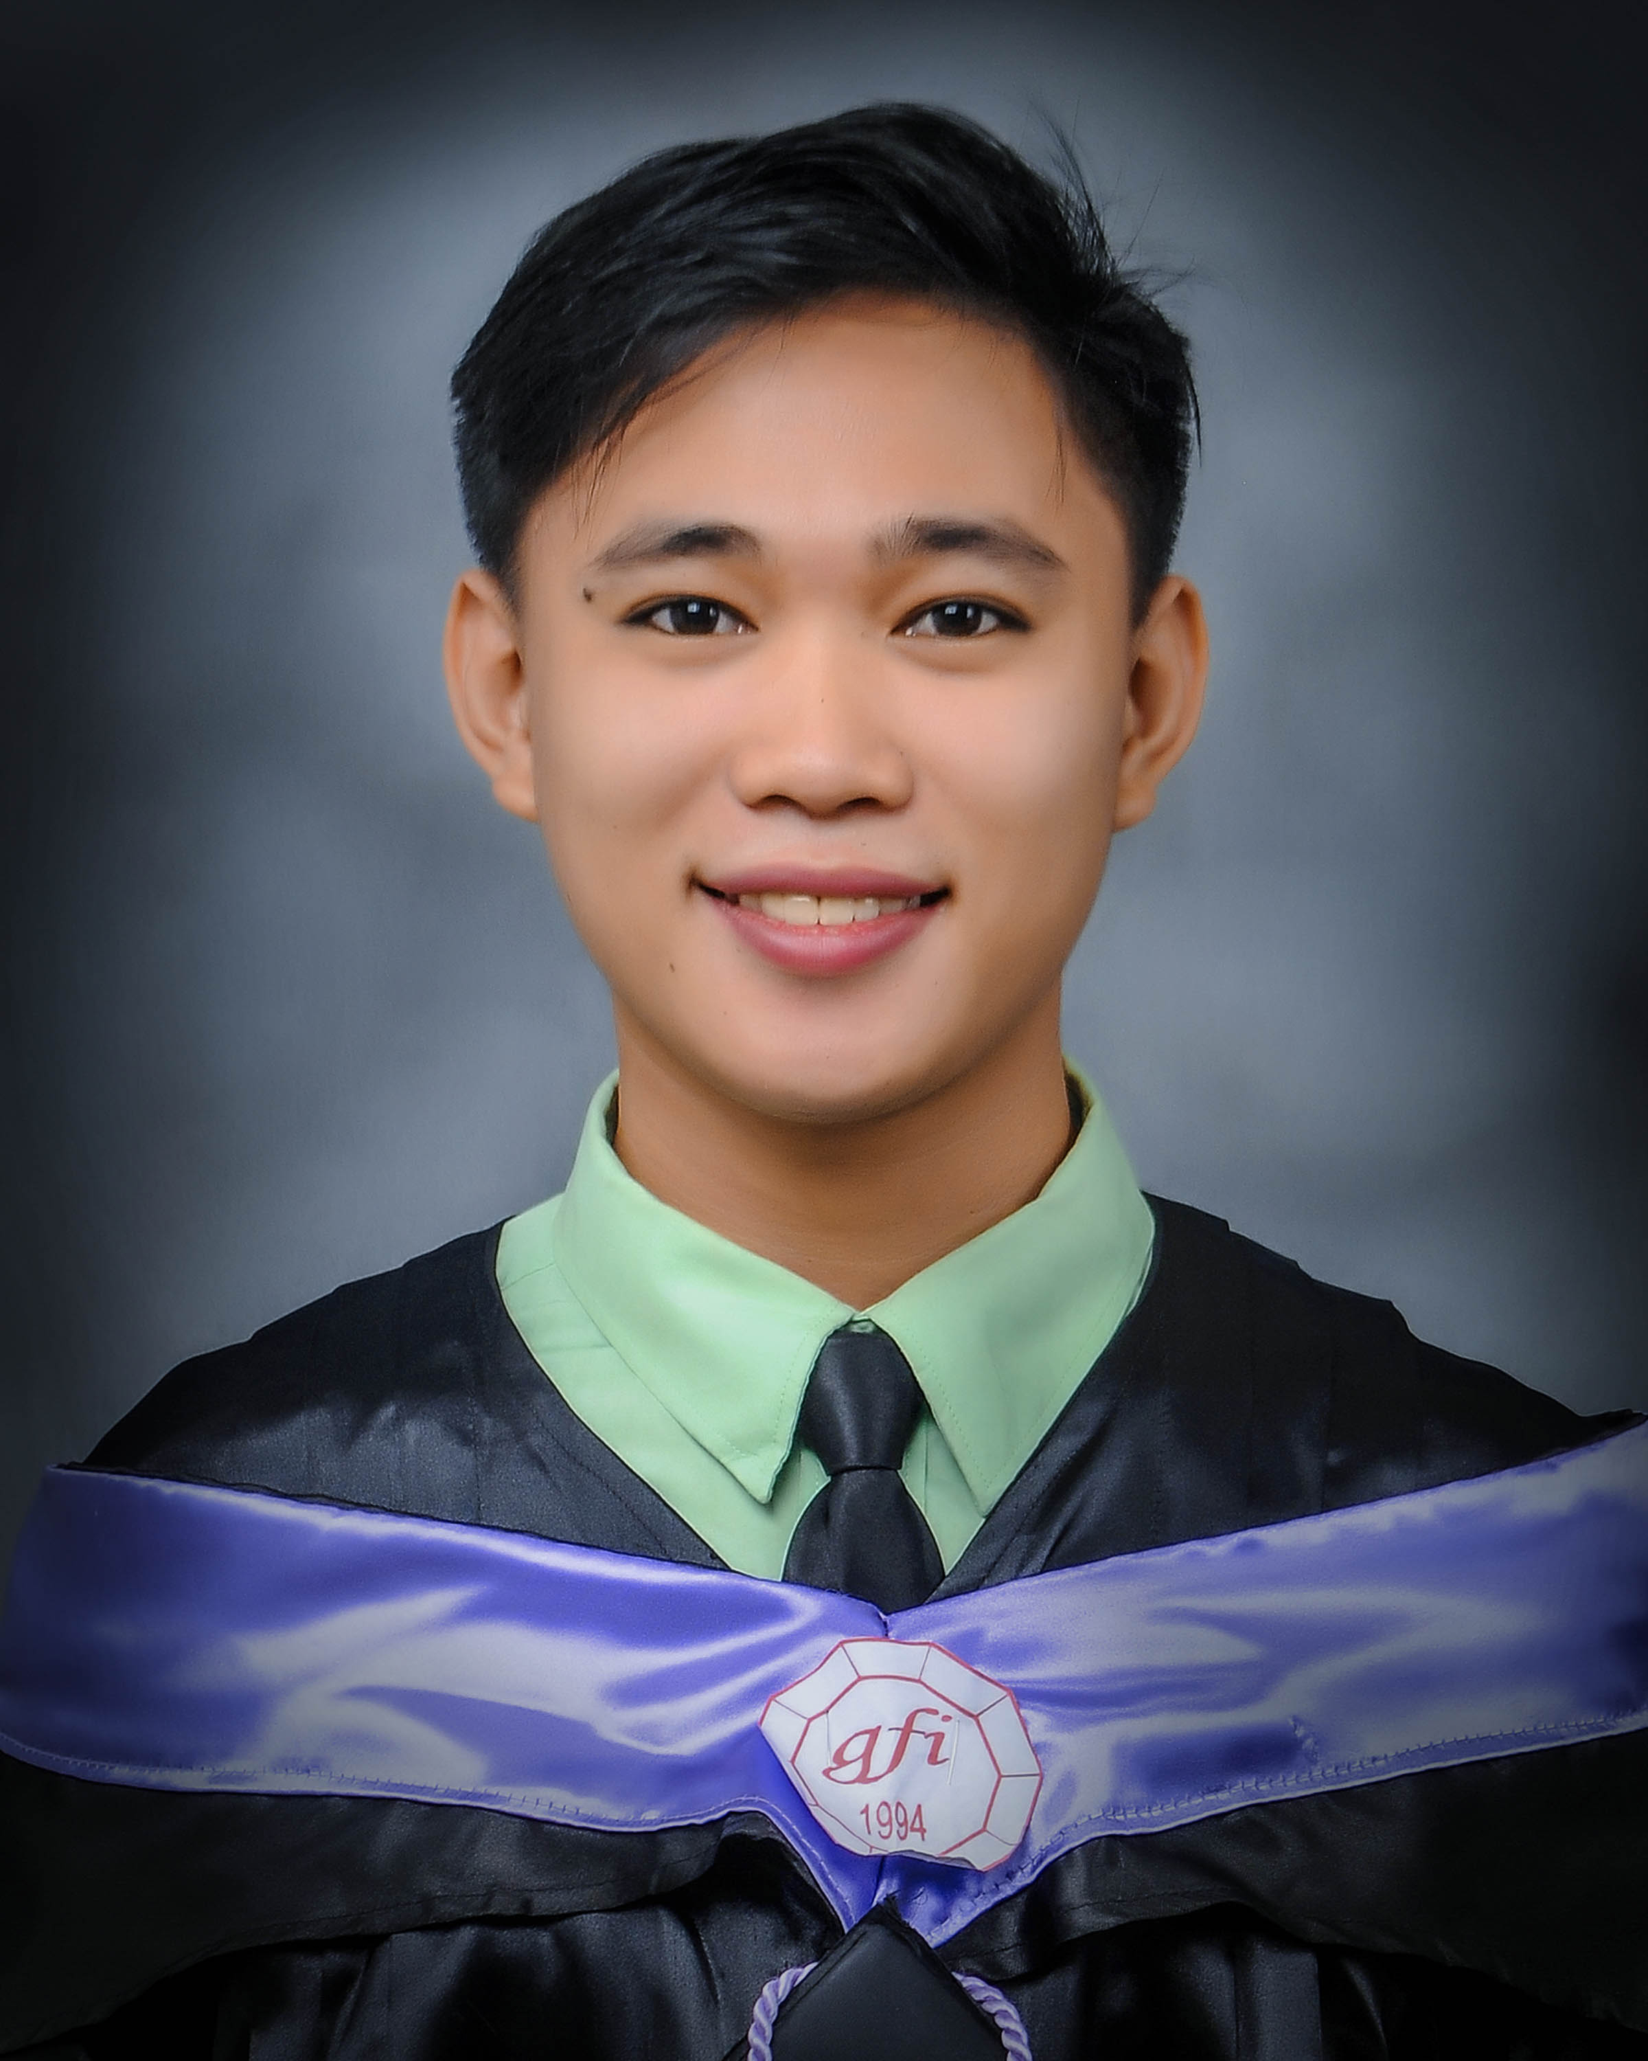
Summary

Well-trained Regular Service Crew for 5+ years of
expertise in food and beverage industry.
Passionate leader to my workmate and know how
to ensure positive working environment. Great
customer service and conflict resolution skills.
And also focused on increasing patronage and
boosting revenues. Offering exemplary food
safety and team development skills.
Raymart P. Pineda
Contact
Address: Purok Malipayon Barangay Labangal General Santos City, 9500

Phone number
09632634579/ 09912969667

Email
raymartpineda70@gmail.com

Skill highlights
• table skirting
• flower arrangement
• make up artist
• cake litterer
• team collaboration
• couching and mentoring
• customer service excellence

Education
2017-2021 - Gensantos foundation College, Inc.
Course: BSBA Financial Management

2012-2014 - Saint John Bosco Institute of Arts and Sciences.
Course: Hotel and Restaurant Management

2017-2011 - New Society National High School

2001-2007 - Pedro Acharon Sr. Central Elementary School
Language
English, Tagalog, Bisaya, Ilonggo

Experience

Red Ribbon Bakeshop Inc.
Regular Service Crew: March 2016 – Present

• Cash handling in different shifts, segregate documents,
…… and filling of documents.
• Displaying cakes, breads and pastries, prepare and
serve food, customer payments, and
provide excellent customer service.
• Ensuring the planogram of cakes, breads and pastries
are follow.
• Develop in-depth training to workers in food
preparation and customer-facing roles to promote
team performance.
• Resolved challenging customer complaints to replace
full satisfaction, promoting brand loyalty and
Maximizing repeat business.
• Determined operational weak points and implement
Corrective actions to resolve.
• Applied knowledge of previous supply needs and
forecasted business levels to estimate required supply.
• Maintained high food quality standards by checking
delivery contents to verify product quality and
quantity.
• Coordinate leadership workshop to educate team.
members on best practices to optimize productive.

(DSWD) Department of Social Welfare Development
Enumerator: August 15, 2015 - October 16, 2015

• Interview all 4P’s members in Maitum province of
Sarangani.
• Evaluate the status of there Livelihood and
do paper reports through the data collected.
• Checking for there Identification card and cash cardsWaite

Watson (316) SMGENSAN
Sales Utility Clerk: March 12, 2015 - August 13, 2015

• Greet customers to welcome them with a genuine smile.
• Ensuring the planogram is in place and accurate.
• Answering any questions they have about the store or what it sells,
suggesting options that fit their needs, providing instruction on using products
and checking customers out when they are finished shopping.
• Assisting customers with exchanges and returns products.
• Setting up merchandise for display, providing training for new sales clerks
and offering customers add-on products and services.
• Manage the shelves by Being outgoing, persistent and able to empathize
with customers is important for making customers feel welcome and valued.

Lex forum function hall/ catering service
Waiter: January 10, 2013 - January 30, 2015

• Clean and prepare the function hall.
• Prepare the tables, chairs and buffet table.
• Put clothes and do table skirting.
• Prepare utensils, like spoon, forks, plates and glasses according to it’s standard.
• Smile and greet customers and welcome the guests and assisting them where
there table.
• Serve them water first.
• Serve the foods and beverages.
• Bass out the plates, utensils and glasses to clean there table.
• Ensure guest satisfaction throughout the meal service.
• Respond to guest requests in a friendly, timely, and efficient manner.
• Respond to and try to full fill any special banquet event arrangements.
• Ensure each courses are cleared and tables are properly crumbed.
• Performing basic cleaning tasks as needed or directed by supervisor.
• Monitor tableware to ensure it is presentable to guests.
• Monitor and maintain cleanliness, sanitation, and organize of assigned station
and service areas.
• Attend tables by removing and separating tableware, plate ware, glassware,
and flatware.
• Ensure proper use, storage of all meeting room equipment.
• Clean the function hall after the event.

