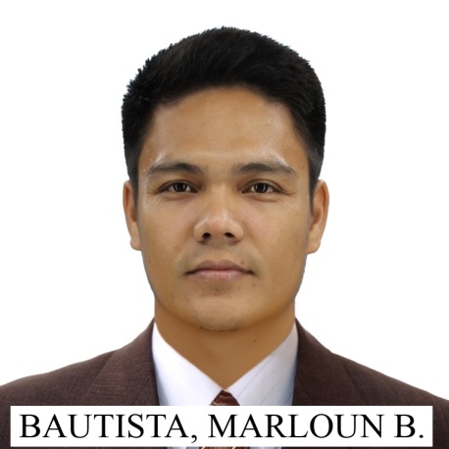
MARLOUN B. BAUTISTA, REE
E-mail Address: marlounbautista@gmail.com
Contact No. / Mobile No.: 09563916761
09230885392

OBJECTIVE
Currently looking for better opportunity, a position suitable with my qualification to showcase my skills and experience for a better future of my career in your prestigious and admired company.

PROFESSION
Registered Electrical Engineer

EXPERIENCES

Lafarge Holcim Philippines Inc. – Cement Manufacturing

Reliability Engineer 1 (March 16, 2016 – Present)
Job Responsibilities / Scope of work:
- Establish, develop and optimize equipment reliability based programs.
- Conduct Root Cause Analysis on significant and repetitive failures on all plant equipment & machinery
- Conduct improvement initiatives and developmental studies / activities

- Develop replacement strategies for major equipment & its auxiliaries

- Observed and complying with OH&S rules and regulation and participating in other company improvement programs.
- Perform equipment condition monitoring
- Develop and implement reliability analysis

EIA Maintenance Supervisor (September 16, 2013 – March 2016)
Job Responsibilities / Scope of work:
- Preparations of necessary manpower, materials, tools and other resources needed for the execution of work orders. Conduct active supervision of EIA maintenance activities with adherence to personnel and equipment safety in line with the EIA section objectives.
- Supervise execution of EIA maintenance activities to ensure safety, quality of work and timely completion
- Continuously embark on EIA activities development efforts to improve performance
- Provide leadership, guidance for EIA technicians
- Observe / comply with OH&S rules and regulations

Electrical Maintenance Electrician (March 01, 2012 – September 15, 2013)
Job Responsibilities / Scope of work:
- Perform preventive and corrective maintenance of all electrical installation and controls.
- Perform on-site troubleshooting and diagnosis of electrical installations breakdown.
- Perform Preventive Maintenance Routine, servicing, repair of defective electrical equipment and system to ensure the required availability, reliability and efficiency.
- Provide the needed technical support and assistance to CCR Engineers in the actual production of cement by monitoring and inspecting product process flow, maintaining the operating lines and all its facilities within the assigned section; ensuring the optimum operational trustworthiness and stability of process machinery and equipment within set standards for capacity utilization, safety, quality and cost.
- Perform commissioning activities of newly repaired, replaced or installed electrical equipment prior to turn-over to production.
- Perform electrical installation and systems performance evaluation and recommend improvements.

Project Assistant Supervisor - Correction of WBI and Safety Hazards (August 1, 2011 – February 28, 2012)
Job Responsibilities / Scope of work:
- Prepare documentation / presentation of Safety and WBI findings. Consolidate all EIA findings.
- Assist / supervise implementation of safety activities & project at plant. Take pictures after correction of findings & update report.
- Assist in updating BOM.
- Assist in updating safety hazard and improvement at database and technical aspect at SAP
- Other clerical jobs such as project reports, etc.

Cadet Engineer - Cement Grinding Plant (March 1, 2011 – July 29, 2011)
Job Responsibilities / Scope of work:
- Hands on training as operator of Finish Mill
- Hands on training as operator of Packhouse

Project Engineer - PMR Optimization (March 23, 2010 – Feb 23, 2011)
Job Responsibilities / Scope of work:
- Evaluate equipment and identify needed PMR based on OEM Manuals, Existing PMR’s and HGRS standard.
- Create PMR procedures including duration, manpower, and frequency.
- Check procedures based on actual set up.
- Validate created procedures on field
- Edit procedure accordingly
- From procedure estimate time of performing the specific task.
- Finalize procedure and present to the team.
- Assist Reliability Engineer in conducting load balancing.
- Conduct all clerical works in regards to the project.
- Coordinates to maintenance and production personnel.

Health and Safety Oriented
Knowledge on SAP
Understand and Interpret Electrical Wiring Design
Flexible-willing to take on a variety of task

SKILLS, SEMINARS AND TRAINING ATTENDED
Certified Machinery Lubrication Level 1 (MLT1)
Center for Reliability Excellence (CRE Philippines)
March 27-30, 2019
Certified Vibration Analyst Category 1
Vibration Institute
March 20 - 24, 2017
Basic Nondestructive Testing (RT,UT,MT,PT)
APEX ENGINEERING SERVICES
November 8-12, 2016
Certified Infrared Thermography Level 1
Certification No. IRT L1 Thermographer # L1-P164
Institute of Infrared Thermography
May 24 - 27, 2016
ETAP 114 PH Power System Analyses
ELTECHS E&C CORPORATION
THE INSTITUTE OF ELECTRICAL AND ELECTRONICS ENGINEERING, INC.
October 13-16, 2015
Motor Circuit Analyses
PdMA CORPORATION
June 2-6, 2014
Electric Motor Maintenance
Slip Ring Motor Maintenance Workshop
Transformer Oil Analysis and Maintenance
VFD Maintenance
Electrical Safety
Motor Operation, Control and Protection

AFFILIATION
Institute of Integrated Electrical Engineers of the Philippines Inc. (IIEE) member.

PERSONAL INFORMATION
Address: Brgy. Almeida, Balaoan, La Union, Philippines 2517
Date of Birth: June 26, 1985

EDUCATION
Tertiary Education:
Don Mariano Marcos Memorial State University
Bachelor of Science in Electrical Engineering
2004-2009

REFERENCES

Engr. Feliciano P. Padua III, PEE
Email Address: starace.trading@gmail.com
Contact No. 09178667662

Engr. Nathaniel M. Acosta
Contact#: Email Address: Nathaniel.acosta@valmet.com



BAUTISTA, MARLOUN B.
APPLICANT

