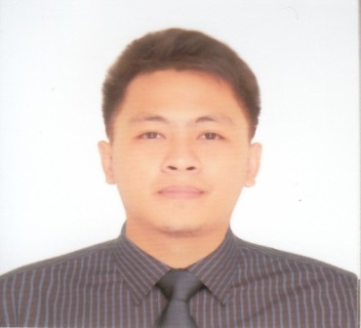
Patrick G. Coralde
Lot 15 blk 6 St. John St. Marvi Hills Subd,
San Mateo, Rizal
09079418205/09171190796
patrick_coralde@yahoo.com/ptrckcoralde@gmail.com

Objective

Obtain a position that will help me use and maximize my customer service and communication skills acquired in my previous fields.

Experiences

- AFNI Philippines Inc.
- Verizon (September 2018 to February 2019)
Customer Service Representative, Chat
- Identifying and assessing a customer’s needs to ensure they are satisfied.
- Contacting customers to discuss your company’s new services.
- Speaking to customers about new charges.
- Handling customer complaints.
- Maintaining customer records by updating their account information.
- Recommending potential products and services to suit a customer’s needs.

- Sutherland Global Services
- Quicken (2014 to 2016)
Customer Service/Technical Service
- Assists American and Canadian Customers
- Helps customer balance and fix their financial concern
- Provide advice with regard to their Bills and Expenses
- Recommends the best product fit for financial capabilities and needs
- Pre sales questions by educating customers about the feature and benefits of the product

- TurboTax ( 2013 to 2014)
Customer Service/Technical Service
- Helps customers to download their tax software and forms
- Helps customers decide what product will suit their needs

Educational Background

College Mariners Polytechnic Colleges Foundation 2009-2013
BSMT
Secondary Camarines Sur National Highschool 2005-2009
Peñafrancia, Camarines Sur

Skills
- Good communication skills ( English, Filipino)
- Customer Service Skills
- High levels of creativity and resourcefulness combined with organizational skills.
- Highly skilled in the use of computer and internet including popular applications such as Microsoft Word and Microsoft PowerPoint.

Personal Information
- Age: 28
- Birthday: August 9,1992
- Civil Status: Married
- Religion: Roman Catholic

References

Sey Cristobal
Supervisor, Talent Acquisition, Concentrix
09992235903

Michael Aguirre
Team Manager, Sutherland Global Services
09484985692

Darlyn Ty
Team Manager, Sutherland Global Services
09173234066/09464721824

ArvindSwarup
Quality Site Manager, Sutherland Global Services
09175089531

