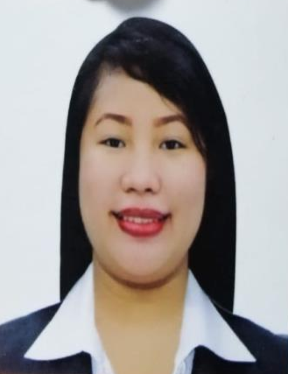
Joy R. Fuentes
Fuentesjoy23@gmail.com
146 Freedom Park 6,
Batasan Hills, Quezon City
Metro Manila, Philippines
(09334632145/09179219893)

Background:
Educational

Tertiary : Quezon City University
Bachelor Science in Industrial Engineering
2018-2021 GRADUATED

Quezon City Polytechnic University
Bachelor Science in Industrial Engineering
2013 – 2015

Polytechnic University of the Philippines
Bachelor of Science in Accountancy
2010 - 2011

Secondary : Batasan Hills National High School
Year Graduated: 2009 - 2010

Elementary : Commonwealth Elementary School
Year Graduated: 2005 - 2006

Information:
Personal

Age : 27
Birthdate : April 11, 1994
Birthplace : Quezon City, Philippines
Height : 5”1’
Weight : 58kgs.
Gender : Female
Nationality : Filipino

Experience:
Work

Philippine Statistics Authority NCR II
Census Area Supervisor – EDSA Grand residences, Brgy. Ramon Magsaysay, Quezon City. Finished Contract (May 2020 –June 2021)

Milktea and Unli Chicken Wings Stop
Supervising Staffs - Novaliches Quezon City
Working Student – August 2018 – Dec 2019

Jordan Trading Group Incorporated
Cashier ( Zeina Mall ) Aqaba, Jordan
March 28, 2016 – April 6, 2018

Baby Sitting/ Math and English Tutor – Aqaba, Jordan
August 2016 – January 2018

Metro Manila Development Authority
Summer Job Internship Program (Office Staff)
EDSA, corner Orense Street, Guadalupe, Makati, Philippines.
April 2012 – May 2012

Bernales & Associate
Account Executive ( Former Chinatrust bank CTBCBNK Account)
EDSA, highway Cubao, Quezon City, Philippines
2014-2015

Character References:

Michael T. Fuentes Raymond Balila
Laundry Manager Supervisor
Saudi Arabia - K.S.A Company: Tim Hortons
Company: Habitas Alula Canada - Fort,Saskatchewan
+966543711139 3066079109


I hereby certify that the above information are all true and correct according to the best of my knowledge and beliefs.

JOY R. FUENTES

