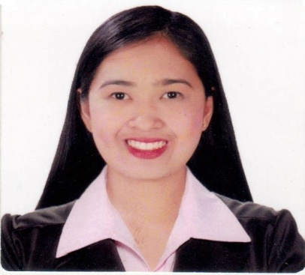
MARICON M. MALLARI
#87 Everlasting St. Santiago Sta. Ana, Pampanga, 2022 Philippines
Mobile No.: 09091850965
E-mail Address: mariconmallari@yahoo.com/mariconmallari121708@gmail.com

OBJECTIVE
To acquire a position that will provide opportunity to apply and further develop my acquired knowledge, skills and training as optimal as possible and contribute to the accomplishment of the institution goals and objectives as well.

PERSONAL DATA

Nickname : Con
Date of Birth : December 8, 1990
Place of Birth : Santa Ana, Pampanga
Age : 31 yrs. old
Sex : Female
Civil Status : Married
Nationality : Filipino
Religion : Catholic
Height : 5’5”
Weight : 110 lbs

EDUCATIONAL BACKGROUND

Tertiary: Bachelor of Science in Tourism Management
Saint Marys Angels College of Pampanga
San Pedro Sta. Ana Pampanga
S.Y 2007-2008
S.Y 2014 –2017, Graduated

Secondary: High School Education
San Isidro High School
San Isidro Sta. Ana Pampanga
S.Y 2003 – 2007, Graduated

Primary: Elementary Education
Santiago Elementary School
Santiago Sta. Ana Pampanga
June of 1996 –April 2003, Graduated

SKILLS (Proficient in the following skills)

- Time management skills with quick learning aptitude
- Productive worker with solid work ethic who exerts optimal effort in successfully completing tasks.
- Confident, hard-working employee who is committed to achieving excellence.
- Ability to handle multiple tasks.
- Great customer service skills

CERTIFICATES

TOUR GUIDING SERVICES NCII
MARCH 23, 2015

FRONT OFFICE SERVICES NCII
MARCH 11, 2016

INTERNSHIP PROGRAM

SUPERSONIC SERVICES INC.
Unit 106 Marlim Mansion Hotel Balibago Angeles City
April 6 - May 18, 2015

CLARK DEVELOPMENT CORPORATION (Clark Museum)
Building 2127, C. P Garcia St. Corner E. Quirino St, Clark Freeport Zone
November 18, 2016 - February 13, 2017

WORK EXPERIENCE

COMPANY: RTD DAVID VENTURES INC. (NIKE ZONE SHOE CENTER)
ADDRESS: G/F SM CITY PAMPANGA, CITY OF SAN FERNANDO PAMPANGA
POSITION: SALES CONSULTANT
AUGUST 6, 2012 - FEBRUARY 15, 2014

Mazda Pampanga
Jose Abad Santos Avenue Dolores City of San Fernando Pampanga
Position: Sales Admin & Dealership Customer Relation Center
August 1, 2017-August 22, 2020

CHARACTER REFERENCES: Furnish upon request
I hereby affirm that the aforementioned information is true and correct to the best of my knowledge and belief.

Maricon M. Mallari

