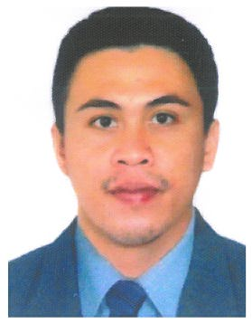
ARNIE M. RAMOS
#182 Guesang Mangaldan, Pangasinan
Contact #+639303674180

POSITION APPLIED FOR : WELDER (Smaw,Gtaw)

PERSONAL DATA

Date of Birth : November 20,1988
Place of Birth : Tuba, Benguet
Age : 30
Sex : Male
Civil Status : Married
Religion : Roman Catholic
Nationality : Filipino
Height : 5’7"
Weight : 70 kgs.
Father’s Name : Buenaventura M. Ramos
Mother’s Name : Teresita M. Ramos

EDUCATIONAL BACKGROUND

TERTIARY : Vocational (PTC) TESDA
Lingayen, Pangasinan
COURSE : Welding
Shielded Metal Arc Welding (SMAW NC II) May – July 10, 2009 Gas Tungsten Arc Welding (GTAW NC II) Aug 3 – September 14, 2009 H.E.O [WHEEL LOADER,BACKHOE LOADER] Feb. -Nov.,2018
SECONDARY : David National High School
David Mangaldan, Pangasinan
2001-2005
PRIMARY : Guesang Elementary School
Guesang Mangaldan, Pangasinan
1995-2001

EMPLOYMENT RECORD

Employer : Keppel Batangas Shipyard
Address : San Miguel Bauan, Batangas
Position : Welder/SMAW,GTAW
Date Inclusive : February 1, 2009 to February 15, 2012

Employer : Asyad International Company (AIC)
Address : Ras Tanura, KSA
Position : Electrical Welder/SMAW,GTAW
Date Inclusive : October 4, 2012 to October 4, 2014

Contactor : LSB Metal Works
Company : Philex Mining Corporation
Address : Padcal Tuba, Benguet
Positon : Welder/SMAW
Date Inclusive : January 16,2015 to August 20,2017

Employer : Safeway Construction and Supply
Address. : #14 Bari Mangaldan Pagasinan
Position : Welder/SMAW
Date Inclusive : September 02,2017 up to date

CHARACTER REFERENCES

Hon. Mary Marilyn D. Lambino : Municipal Mayor
Mangaldan, Pangasinan
Engr. Luis S. Bautista : LSB Metal works owner
Calasiao, Pangasinan
Engr. Mario G. Lim : Safeway Managing Officer
Mangaldan, Pangasinan

I hereby certify that the above information is true and correct to the best of my knowledge and belief.

Applicant Signature

