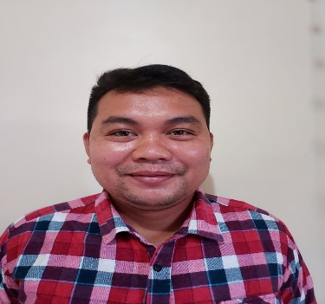
Richard G. Calurasan

Contact Information
Zone 1 San Francisco, Buhi Camarines Sur
09165721552
calurasanrichard@yahoo.com

Skills
- Highly organize
- Detail – oriented
- Service focused
- Excellent communication skills

Work Experience
Carnival Cruise Line
Store Keeper
March 2018 – till Present

Padi House
Restaurant waiter/Bar waiter
March 2016- December 2017

Kudu Restaurant
Headwaiter
February 2014- Febraury 2016

Education
Cagayan de Oro College
Bachelor in Science Criminology
2004-2005

OPOL National Secondary Technical School
2000- 2004

References
Nerio Sonsona
Manager
09456926411

Luis Harris Pulgar Cortes
Manager

