Jonalyn Bangayan Miguel
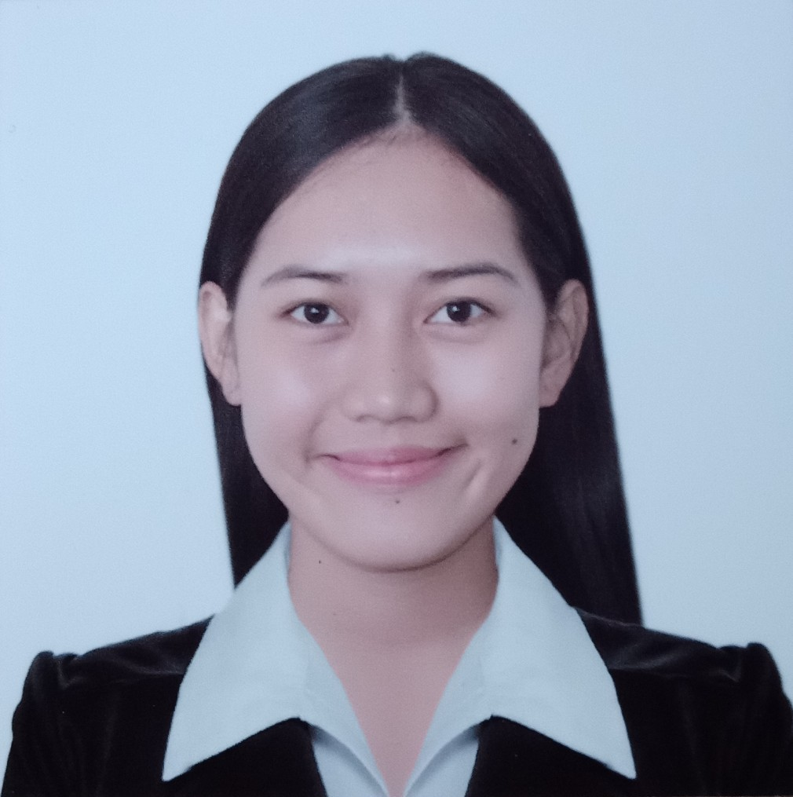

Attach Here
v2x2
Colored Picture
29F Seminary Road Bahay Toro, Quezon City
Philippines, 1300
Phone No.: (63) 9086534310/ 9452711635
Telephone No.: 863-0800 local 118
Email Add: joannemiguel17@yahoo.com

PERSONAL INFORMATION

Permanent Address : Solana, Cagayan Philippines, 1300
Birthdate : January 17,1994
Birth Place : Solana Cagayan
Height : 5’6 ft.
Weight : 127 lbs.
Sex : Female
Civil Status : Single
Religion : Roman Catholic
Nationality : Filipino

BENEFICIARY

Beneficiary Name : Miguel, Eufemia Bangayan
Relationship : Mother
Permanent Address : Solana Cagayan, Philippines 1300
Tel. No. : 009733418764

DEPENDENTS:

Father: Miguel, Eleuterio Semana Birthday: December 1,1966
Birth Place: Tuao Cagayan
Occupation: Farmer

Mother: Miguel, Eufemia Bangayan Birthday: April 19,1966
Birth Place: Solana Cagayan
Occupation: Domestic Helper

BROTHERS / SISTERS

Brother: Miguel, Joven Bangayan Birthday: September 2,2002
Birth Place: Solana Cagayan
Civil Status: Single
Occupation: Student

Sister: Miguel, Joylyn Bangayan Birthday: October 19,1987
Birth Place: Solana Cagayan
Civil Status: Single
Occupation: Pharmacy Assistant

EDUCATIONAL BACKGROUND

Elementary Year [From] - [To]
School: Padul Elementary School 2001-2007 Address: Solana Cagayan

Secondary
School: Sampaguita National High School 2007-2011 Address: Solana Cagayan Philippines

College
Course: Bachelor of Science in Radiologic Technology 2001-2007
School: Medical Colleges Of Northern Philippines
Address: Alimannao Hills Penablanca Cagayan, Philippines

EMPLOYMENT HISTORY

Position: X-ray Technician/Clerk
Company: Address: Seminary Road, EDSA,Quezon City, Philippines
Date: August 04,2017 to present
Reason for Leaving: N/A

Job Description / Duties and Responsibilities:
- Received and charged examination request Form from ER and all Wards unit as per doctor request
- Encode patients data and results
- Help maintain adequate records and communication letters
- Give instructions (e.g patient preparations and procedures)as necessary
- Releasing results of Diagnostic examination such as X-RAY, CT-SCAN, MRI and ultrasound.
- Assist Radiologist in performing special procedures such as, Biopsy, Paracenthesis and Thoracocenthesis
- Perform Mammography Procedure

Position: Assistant Radiologic Technologist
Company: Aventus Medical Care Inc.
Address: Comfoods Bldg. Chino Roces, Makati City
Date: April 11, 2016 to September 12, 2016
Reason for Leaving: Finish Contract

Job Description / Duties and Responsibilities:
- Competent in assistingwith imaging process
- Perform clerical duties including record keeping, and maintain high quality services
- Communicates effectively with patients, families and all care providers.

TRAININGS / SEMINARS ATTENDED

Training Center: QCGH SB HALL Duration: June 14,2017
Address: Quezon City General Hospital, Philippines
Title: ISO 9001:2015 Awareness

Training Center: SB Belmonte Hall, Qc Philippines Duration: March 21-22,2018
Address: Quezon City General Hospital, Philippines
Title: 5’s + 1

Training Center: Radiology Department Qcgh,Philippines Duration: March 8-12,2018
Address:Quezon City General Hospital
Title: Samsung GC70 Digital Radiography System End User Training
SPECIAL SKILLS / INTERESTS
- Hard working and Flexible,Adapt easily to change environment and work on schedule.
- Sensitive, caring and professional attitude toward staff
- Ability to elicit confidence and build rapport
- Competent, fast learner and able to work under pressure
- Highly motivated and committed to getting the job
- Proficient in the use of computer

CHARACTER REFERENCES
Marie Nell N. Ragunjan, M.D, FPCR,FCTMRISP
Chairman of Radiology Department

Mr. Rommel A. Alivo,RRT
Chief Tech. of the Department
Board of Director of PSGRT
Tel. No.: 09476119935

Hon. Jenalyn Carag
Municipal Mayor
Solana Cagayan

_________________________
Applicant’s Signature

