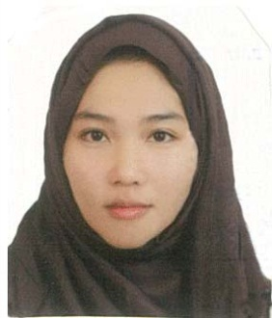
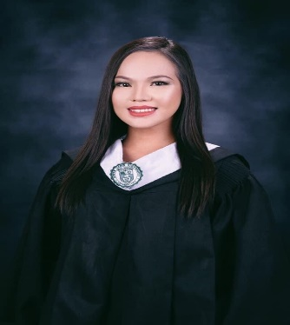
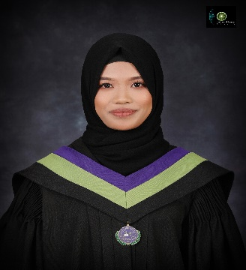

DIANE MARIE G. ABDESSALAM
PERSONAL DATA
Name: Diane Marie G. Abdessalam
Date of Birth: October 12, 1986
Gender: Female
Marital Status: Married
Nationality: Filipino
Address Residence: Catitipan Aiport Rd., Buhangin, Davao City, Philippines, 8000
Religion: Islam
Email Address: zahrahabdessalam@gmail.com
Mobile Number: +639061305001 / +639129020533
EDUCATIONAL ATTAINMENT
TERTIARY : Davao Doctor’s College
Bachelor’s Degree of Science in Nursing
School Year: 2004 - 2009

: University of Mindanao (UM)
Matina Campus, Davao City, Philippines, 8000
Vocational Courses in Caregiving & Health Care Services
School Year: 2017 - 2018

CERTIFICATION / LICENSES

National Certificate Level II: Caregiving (Passed)
Certificate No. 18112402029300

WORK EXPERIENCE

- Nursing Attendant (February 1, 2021 – January 31, 2022)
#723, Molave St., Juna Subdivision, Brgy. Matina Crossing 74-A, Davao City, 8000, Philippines

- Virtual Agent (August – November 2020)
DYNATA GLOBAL PHILIPPINES
4F Cybergate Delta, J.P. Laurel Ave, Bajada, Davao City, Philippines, 8000

- Call Center Agent (November 2017 – April 2018)
FLATWORLD SOLUTIONS PHILIPPINES, INC.
Aeon Towers, J.P. Laurel Ave., Davao City, Philippines, 8000

- Assistant Supervisor (January 2013 – June 2016)
NABUNTARAN LIME 33 AGRI & INDUSTRIAL SUPPLY
Purok 3 Km. 94 Nabuntaran Magsaysay 6003 Compostela

- Receptionist / Telephone Operator (September 2012 – January 2013)
FHS LAW FIRM (UEA, DUBAI)
Sea Tower, Office No. 201, Raffy St., Near Abu Dhabi Chamber of Commerce

- Receptionist (March 2012 – August 2012)
EMIRATES FALCON ELECTOMECHANICAL COMPANY (EFECO)
Le Solarium Tower, UEA

- Call Center Agent (August – February 2012)
SUTHERLAND DAVAO
Luisa Square, IT Building Villamor St., Corner Emilio Jacinto Ext., Davao City

- Private Teacher (June – August 2011)
BETHEL LEARNING CULTURAL CENTER (BLCC)
Km 3 Gen. Douglas MacArthur Hwy, Talomo, Davao City

CHARACTER REFERRENCE

- Gerlaine Corpuz Balmorez
ICD-10 Coder
Mecca IClinic Foundation, Inc. – Davao City
Mobile #: (+63) 9172046640
Email Add: gerl_corpuz@yahoo.com

