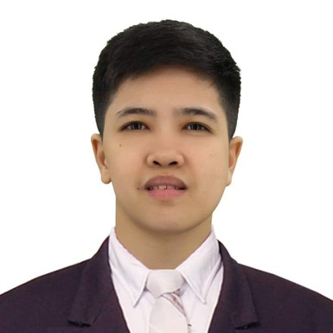
Katrina Celine L. Francisco
Unit 041, 1317 Priscilla St. Sta.Cruz, Manila
franciscokatrinaceline@yahoo.com
+63 919-065-91-38

Career Objective:
Seeking a position in a progressive organization where I can fully utilize my education and professional experiences and provide me career growth and opportunity to work with highly competitive professionals with a common vision of leadership in a dynamic environment.

Work Experiences:

Room Attendant/Team Leader –Current Employer
Winford Manila Hotel and Casino
San Lazaro Tourism & Business Park, MJC Drive, Sta.Cruz, Manila
April 4, 2018

Job Responsibilities of Housekeeping Room Attendant
•Cleaning of Rooms, Carpets, Hallway,Pantries,Guest Landing and Service Landing.
•Reporting Room Malfunction/Lost and Found if any.
•Checking of Inventory of Products/linens (Occupied or Vacant).
•Knowledge in Safety Measures during Pandemic.
•Knowledge in using of Floor Polisher and Extractor.
•Providing great customer service by always being polite and professional.

Being a Team leader
•Preparing Daily Worksheet/Floor Assignment (Distribute to Room attendants).
•Daily discussion of Hotel room fundamentals..
•Room Inspection (Only when Authorized by the Housekeeping Manager).
•Reporting of room engineering concern (wall/carpet/faucet/door knobs/ceiling for repaint/repair)
•Pre-shift and post shift, briefing/endorsement of reported concern.
•Coordinating with different departments about hotel concern.
•Making Rounds (Casino, Back office, Perimeters)

Skills
•Ability to work under pressure.
•Ability to work on flexible shift including overnight, weekends and holiday on rotation basis and extended work hours when needed.
•Has a strong focus on attention to details.
•Has a strong sense of teamwork and committed to the team.
•Is flexible to accept assignment when required to assist with room cleaning and other tasks.

On Call-Room Attendant
Conrad Hotel Manila
Seaside Boulevard, Coral Way, Pasay City
June 30,2017– January 2018

On-The-Job Training:
Room Attendant
The Midland Plaza Training Center
M.Adriatico Street Ermita, Manila
February – May 2011
(600 Hours of Training)

Educational Attainment:
Tertiary Education School
Bachelor of Science in Hotel and Restaurant Management
Lyceum of the Philippines University
Intramuros, Manila City
2007-2011

Personal Information:
Birthdate: July 02, 1985
Birthplace: Manila
Height: 5’2’’ Weight:130 lbs.
Religion: Roman Catholic
Nationality:Filipino
Civil Status: Single

Character References:
Justine Anne Vergara
Duty Manager Front Office
Winford Manila Resort and Casino
09362805956

Maria Ericka Montoya
Cleaner
Royal Caribbean Cruise Line
09454969466

