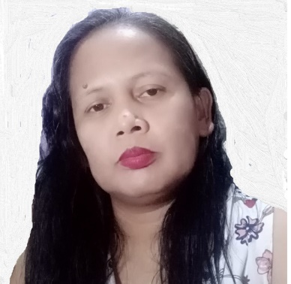
GINALENE BAYLON CONCHA
246 Paraiso Street, Casimiro Village, Las Pinas City
Contact no: 88731237 / 09272611443
Email: ginabconcha@gmail.com

Work Experience

Ibex Inc.
August 2020 – Present
Chat Support/Email Support Agent
- Provides assistance to customers in placing order, track their orders, process refunds and replacement requests, and help them troubleshoot system issues they encounter with the app.

Teletech Inc.
Sept 2010-Dec 2015
Customer Service Representative
- Provides assistance to the dealers/callers by processing their requests.
• Provides information to the dealers seeking clarifications on their customer’s account, e.g. billing information
• Help dealers troubleshoot and solve their customer’s concerns/problems, and escalate it to the proper department if needed.

UENAI, Inc.
Freelance Homebased editor
Mar 2009-Aug 2010
- Edits essays written by Korean students.
- Grades the essays and educate the students on how they can improve their essays and their grammar.

SCOPEWORKS ASIA, INC.
Conversion/Escalation Agent
Jun 2008-Feb 2009
- Converts voicemail messages into text messages for clients in USA
• Make sure that the accuracy and speed standards are met.

APAC CUSTOMER SERVICES, INC.
Inbound Customer Service Representative
Apr 2006-Oct 2007
- Provides information and assistance to the Physicians regarding their patient’s Health Care coverage.
• Assists the Physicians with the status of their claims.

AIG BUSINESS PROCESSING SPECIALIST, INC.
Business Processing Specialist
Jul 2002-Dec 2005
- Responsible in the data entry and processing of insurance applications for clients abroad.
• Responsible in requirements management and order requests for medical records from the physicians for the client’s insurance applications via email.

SYDENHAM Laboratories
QA Analyst
- Perform laboratory experiments to make sure all the products passed the quality parameters set by Bureau of Food and Drugs.
- Inspect the Production Area to ensure the personnel are complying to the QA Guidelines.

NEC Components, Inc.
PROCESS ENGINEER
November 2000 – April 2001
- Responsible for troubleshooting and improvement of the PWB (Printed Wiring Board) Plating line.
- Reports to the management the monthly output, all the challenges and solutions, and productivity of the Plating line.

Education

College Mapua Istitute of Technology
BS Chemical Engineering
1994-1999

Secondary University of Perpetual Help System DALTA
1990-1994

Elementary Gueguesangen Elementary School
1984-1990

Personal Information
Age : 44 years old
Date of Birth : November 20, 1977
Gender : Female
Status : Married

