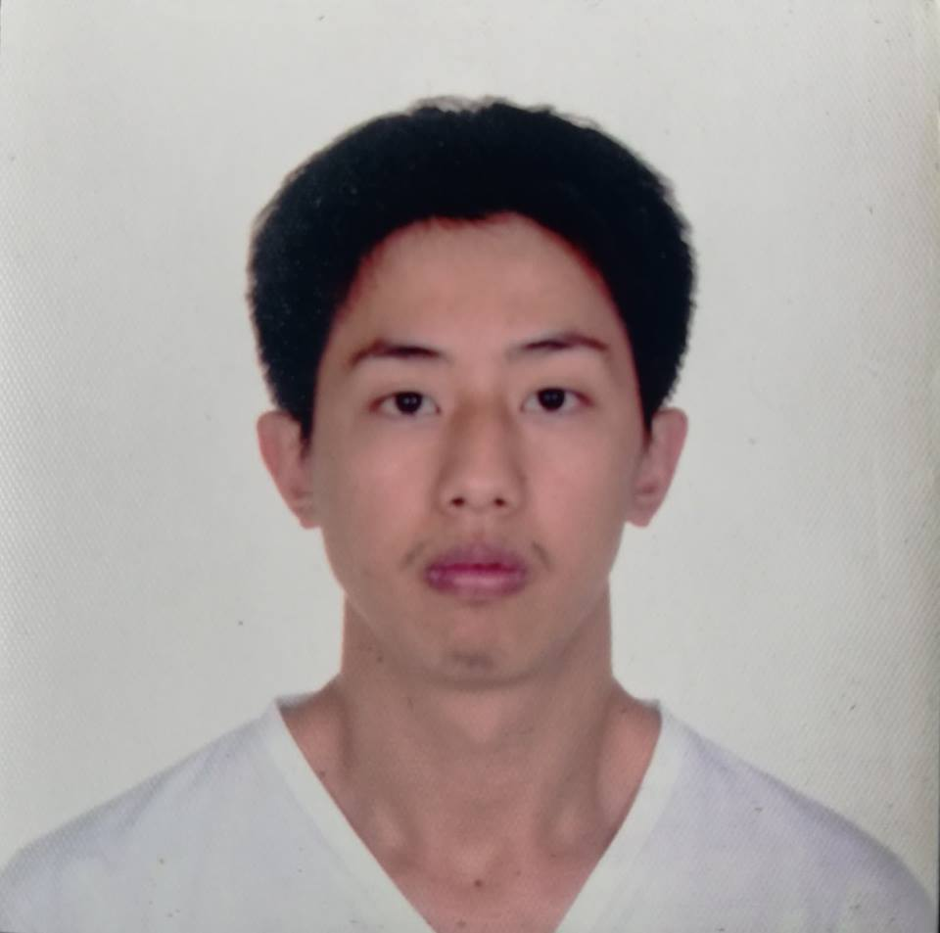

ALFREDO B. BULAY, Jr.
Regal Lexber Homes, Tadiangan
Tuba, Benguet
+63946-938-5506
albulayjr@gmail.com

WORKING EXPERIENCE
Title | Venue | Inclusive Dates
On-The-Job Training  (UB Electrical Department) | University of Baguio | August – November 2018
Machine Operator | Fine Pure Drinking Water | January-May 2020
Freelance Basic Car Detailer | Baguio | June-December 2020
Generator Technician | Baguio | March 2021-Present

EDUCATION

2009 Kings College of the Philippines
Automotive Servicing NC I
Km 4, La Trinidad, Benguet

2011 RTC-TESDA BAGUIO
Automotive Servicing NC II
Loakan, Baguio City

2012-2018 University of Baguio

(Tertiary) Bachelor of Science in Industrial Technology,
Major in Mechatronics
General Luna Road, Baguio City

SKILLS AND ABILITIES
- Basic Metal Fabrication
- Basic Welding SMAW
- Basic Electrical Wiring
- Basic Electronic Troubleshooting
- Car Maintenance
- Basic Car Detailing
- Genset Maintenance and Troubleshooting

ADDITIONAL INFORMATION

- 29 years old
- Team player
- Fast learner
- Athletic
- With Drivers License 2 and 4
- Positive goal

HOBBIES

- Basketball
- Travel
- Swimming

REFERENCES

Engr. Bernard Z. Abaya
CPDO Director
University of Baguio
0915-769-8994

Engr. Romulus M. Amistad
Professor, School of Engineering and Architecture
University of Baguio
0908-466-9514

