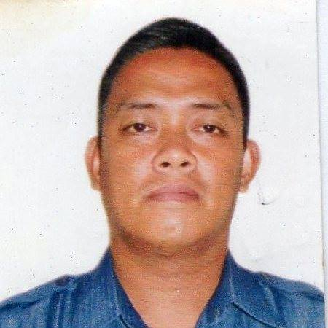
Jesus Y. Manuel Jr.
804 Endaya St Tondo Manila
Contact #: +63 9061463227
Email Address: shasha.jhun@gmail.com

Objective: To improve my skills and ability in the field I’m applying. And to give good service in the company I’m working as well to the people I am serving with.

Professional Experience:
Professional Driver
2005-Up to Date
Licence Number: NO498411432

Puregold Price Club Inc.
Puregold Tayuman
Truck Driver
October 31, 2005-December 5, 2005

SR-5 Corporation
Shakey’s España
Kitchen Crew
February 17, 2002-July 30, 2002

Jericho G Foods Corporation
Jollibee Tayuman
Service Crew
March 25, 1998-July 04, 1998

Educational Back Ground:

Manuel L. Quezon University
Bachelor of Science in Criminology
1996-2001 _College Graduate

Personal Background:

Birth Date: August 07, 1979
Status: Married, 3 Kids
Name of Spouse: Melissa N. Manuel

Character References:

Mary Rose Segarra
Quezon City, Philippines
09098534699

Emily Chaliongco
Endaya St. Tondo Manila
(02) 5595457

