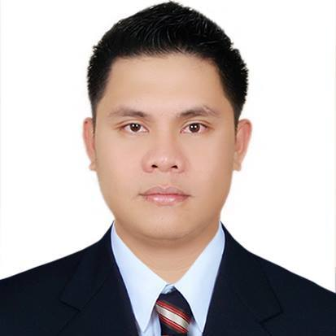
ROALD RYAN B. CORONEL
Calawisan, Lapu-lapu City, Cebu
Contact no. 09454212475
croaldryan@yahoo.com

OBJECTIVES:

To attain an excellent height in the energy industry and contribute in experiencing the knowledge in the field of endeavour from my acquire skill and work experience.
To be part of company where I can improve my knowledge and skills.

PERSONAL BACKGROUND:

Birth date : July 30, 1984
Birth place : Cebu City, Philippines
Civil Status : Single
Citizenship : Filipino
Religion : Catholic
Height : 5’8”
Weight : 190 lbs.

EMPLOYMENT HISTORY :

CHOWKING(Fresh N’ Famous)
Senior Crew(Kitchen)
Sept.16,2019-upto Present

Crimson Resort and Spa Mactan
Laundry Attendant
May 24 2018 –up to present
Sorts dried articles according to type.
Folds and places item in appropriate storage area.
Sorts and counts articles to verify quantities on laundry requisitions.
Clean lint traps and sweeps laundry room.
Operates laundry machinery such as washers, driers and ironers.

AL JABER CATERING SERVICES LLC ( ABU DHABI, UAE )
Waiter
July 17 2016 –Oct. 25 2017

Americana (Kuwait Food and Company) December 21, 2011-december 21, 2013) (UAE)
PIZZA HUT (Dubai, UAE)
Team Member

Movenpick Resort and Spa (January-June 2011)
Laundry Attendant

Crimson Resort and Spa ( December 2009-January 2011)
Linen Runner Attendant

Days Hotel (on job training) (October 2008-February 2009)
Waiter
Taking orders, Serves food what they ordered, maintain cleanliness in the establishment and make sure that the food hot and fresh.

Mactan Majestic Restaurant (on job training) (November 2006-March 2007)
Waiter
Taking orders, Serves food what they ordered, maintain cleanliness in the establishment and make sure that the food hot and fresh.

E6 Catering Services (2009-2010)
On-Call Waiter
Prepare all the things for the occasion, serve the customer satisfaction, dish out use items in the particular event such as plates, glasses, and other utensils.

EDUCATIONAL ATTAINMENT :

Tertiary Education : Bachelor of Science Hotel & Restaurant Management
University of Cebu Lapu-Lapu and Mandaue
A.C. Cortes Ave., Mandaue City, Cebu Philippines
2005-2009
Secondary Education : Saint Alphonsus Catholic School
Lapu-Lapu City, Cebu
1997-2001
Primary Education : Saint Alphonsus Catholic School
Lapu-Lapu City
1991-1997

