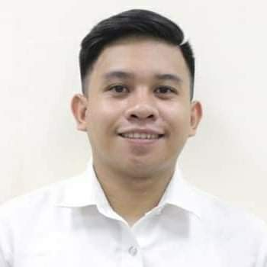
Zean Vincent P. Zausa
Blk. 1, Lot 2, 21 Galvez St. Sta Lucia, Novaliches, Quezon City Contact No: 09982569741

OBJECTIVE:
To work in an organization where I can apply my experience in installation of high-tech equipment, processing and management. To gain new experience and utilize my organizational, communication and interpersonal relationship skills in a challenging, creative and stable environment.

WORK EXPERIENCE
Site Acquisition Engineer/Lease Package Documentation officer
Commsec Inc. (Huawei-Globe Project)
2259-B Aurora Blvd, Pasay, Metro Manila, Philippines
February 2021 to present.

DECRIPTION OF JOB RESPONSIBILITIES

- Responsible for processing the needed documentations during Site Acquisition project phase of Site Development.
- Identify candidates for specific land leases based on customer criteria, owner interest, and jurisdictional Zoning.
- Negotiate and coordinate lease agreement required for the telecommunications installations with the land owner/s and HOA representative – in case the site is within a subdivision.
- Process completion of Zoning and Permit applications for submittal to local governments for approval.
- Monitor sub-contractor’s daily progress to ensure project completion within target.
- Assist Project Manager to ensure whether the project is meeting with the KPI's and quality requirement.

On the Job Trainee
St. Luke’s Medical Center
279 E Rodriguez Sr. Ave, Quezon City, 1112 Metro Manila, Philippines April 2019 to July 2019.

DECRIPTION OF JOB RESPONSIBILITIES

- Have a knowledge and training on how to fix hospital equipment in case of damage or error.
- Conducts regular preventive maintenance on class I biomedical equipment as per approved PM calendar as well as emergency troubleshooting and repairs upon the requests of the end-user.
- Provides satisfactory solutions concerning technical difficulties and makes necessary recommendation.
- Requisitions of materials and tools needed for the repair, troubleshooting and preventive maintenance of biomedical equipment.
- Prepares and submits weekly, monthly accomplishments and operation status reports.

ACTIVITIES AND ORGANIZATIONS
- Drum and Lyre member during High School SEMINARS ATTENDED
IECEP QSCS – Student Summit Seminar – Don Bosco College – Student Hall (2016) IECEP QSCS – Arduino Seminar – New Era University – PSB MPH (2017) Introduction to Biomedical Engineering – New Era University – AVR 1 (2018)

Power Electronics
University Hall, New Era University
Association of Electronics and Communication Engineering Student

Introduction to Electronics Communication System – New Era University – PSB MPH (2018)

Introduction to Power Electronics – New Era University – AVR Lecture Room A (2018)

PERSONAL DATA:

Date of Birth : December 13, 1998 Place of Birth : San Juan City
Civil Status : Single
Age : 22
Religion : Iglesia Ni Cristo
Citizenship : Filipino EDUCATION:
TERTIARY : New Era University
Course: BS- Electronics Communication Engineering (Year Graduate: 2015-2020)

SECONDARY : Sta. Lucia High School
(Year Graduate: 2011-2015)

PRIMARY : San Gabriel Elementary School
(Year Graduate: 2005-2011)

ORGANIZATIONAL EXPERIENCE:

Association of Electronics Engineering Student (SPORTS COMMITTEE)2019-2020

CHARACTER REFERENCES:

Songee Noceda Tax Specialist
Shell Business Operations 09202736011 / snoceda14@gmail.com

Alma Fatima Singson
SAQ Engineer
Commsec Inc.
09668925373 / almaf.commsec1@huawei-partners.com

Patricia Almodiel
SAQ Engineer
Commsec Inc.
09953914458 / map.commsec1@huawei-partners.com

