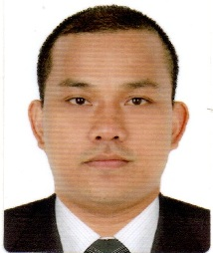
MARLON V. SUBANG
224 vrama avenue englis
sitio sudina cebu city
Contact #: 09082090329
Email Add: marljuv29@yahoo.com

EDUCATION

College level : University of Cebu, Cebu City
Bachelor of Science in Hotel Restaurant Management
  - : Abellana National High School Cebu City
1994-2000 : City Central Elementary School Cebu City
April 25 - June 18, 2011 : SMAW (Shielded Metal Arc Welding)
BMC Training Center for Welding and Fabrication

KEY COMPETENCIES
Highly organize
Efficient
Honest and Responsible
Computer Literate

EMPLOYMENT RECORD
From: To: Position Company
06/27/09 01/10/10 Merchandiser Kraft Foods Phil.
02/02/10 02/20/11 Dough/make person Pizza Hut Phil.
08/20/13 08/20/16 Banquet Waiter Waterfront Hotel & Casino
01/11/17 09/27/17 Utility Cleaner Regent Seven Seas
04/2018 03/25/20 Utility Cleaner Mediterranean Shipping Company
06/10/2021 up to present Messman Bernhard Schulte Shipmanagement

CHARACTER REFERENCES
Mr. Raul Tanggarorang
Waterfront Banquet Manager
09177218475

Mr. Gil Sunpayco
Waterfront Banquet Supervisor
09995875889

