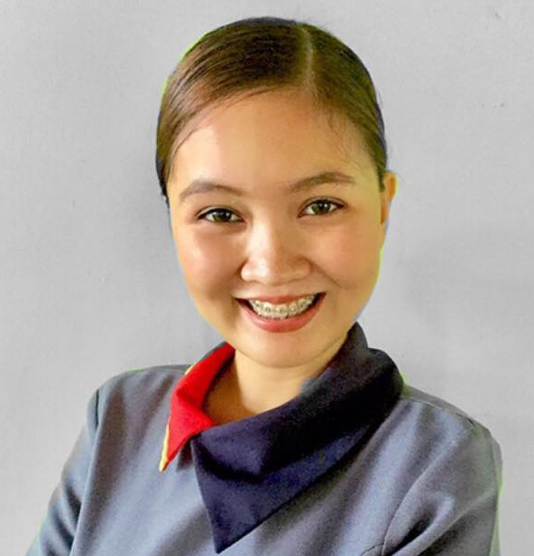
Rio Joyce Octaviano Selin
Consolacion, Agoo, La Union
+639958620159
selinriojoyce@yahoo.com

Career Objective
To be successful leader in operations management where I can utilize my potential and capabilities to achieve the organizational objectives and seize the opportunities for professional development

Working Experience

February 2017-Present
Assistant Restaurant Manager
Jollibee Foods Corporation
Bauang, La Union(February2017-December2019)
Agoo, La Union(January2019-Present)

August 2016 – February 2017
Management Trainee
Jollibee Foods Corporation
San Fernando, La Union (August 2016- December 2016)
Bauang, La Union (January2017- February2017)

December2015-May2016
Service Crew
Jollibee Foods Corporation
Counter
Agoo, La Union

November-December 2014
On-The-Job Training
Universal Leaf Philippines Inc.
Engineering Department
Engineering Clerk
Agoo, La Union

April-May 2014
Summer Job
Universal Leaf Philippines Inc.
Engineering Department
Encoder
Agoo, La Union

Awards

- Drive Thru Rookie of the year 2017
- Drive Thru Olympics contender 2018
- 31st FSC Star Awards 2017
- 32nd FSC Star Awards 2018
- 33rd FSC Star Awards 2019
- 17th Presidential Awards for Performance Excellence 2018
- 18th Presidential Awards for Performance Excellence 2019
- Double One Hundred 2019

Demonstrated Skills/Abilities
- Excellence in Customer Service
- Outstanding People/ Man Power leader abilities
- Cash Control implements cash control plan and cash budgeting
- Payroll monitor and management plan for effective labor cost
- Ensure proper training for employees to improve sales and customer service skills
- Implementing marketing strategies and raw materials
- Excellent communication, both verbal and written

Key Responsibilities Area
- Service and Kitchen Manager: To lead and help the team, to serve a gold standard food with a jolly experience for our customer.
- Drive thru Manager: To Lead the drive thru team, right manpower and strategies for us to serve a fast, friendly service.
- Cash Control Manager: To lead and help the team in terms of
Store cash: processing of store cash, checking all cash matters and legal papers.
Store budgeting: helping to budget the store every month to achieve the store target sales while giving our customers a delightful experience through dine in, take out and drive thru.
Standard processes: To Lead and help for maintaining the team to follow the standard process in the company’s way.
- Marketing Manager: To lead and help the team on marketing strategies to improve the sales performance.
- Billing In charge: In charge of processing and payment for the Electric, Water, LPG (Liquefied Petroleum Gas), Metro Guards Billing.

Educational Attainment
Caregiving NCII
Agoo Technical Vocational Education Training Center
Agoo, La Union
November 2015 - July 2016
Bachelor of Science in Computer Science
Don Mariano Marcos Memorial State University
South La Union Campus
Agoo, La Union
June 2011 - March 2015
Secondary Education
Agoo Montessori Learning Center and High School Inc.
Agoo, La Union
June 2006 -March 2011

Personal Information

Birth date: January 31,1995
Age:26
Status: Single
Citizenship:Filipino
Religion: Roman Catholic
Father’s name: Reynaldo Selin
Mother’s name: Benedicta Selin

Character Reference

Ms. Geraldine Berber
Former L&D Partners
Jollibee Foods Corporation
Ortigas, Pasay City
+639209451336

Mr. Randy Ancheta
Engineering Department Head
Universal Leap Philippines Inc
Agoo, La Union
+639178054638

Mr. Reniel Cuyo
Service Supervisor
McDonalds Restaurant Farm Valley
Moose Jaw, Saskatchewan
6395382530

I hereby certify that the above information are true to the best of my knowledge.

Rio Joyce Selin
Applicant

