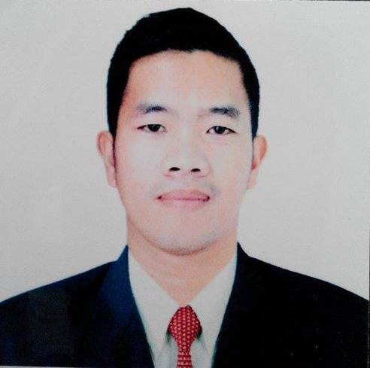
Mark Erick B. Manansala
Block 206 Lot 33 Acacia St. Pembo Makati city, Philippines
CONTACT NO. 09753987445 / 09213615744
EMAIL ADD. : markmanansala2013@gmail.com

JOB TARGET:

- FIRE ALARM TECHNICIAN
- ELECTRONICS TECHNICIAN

OBJECTIVE:

- To Decide on the most appropriate course of action, and accordingly in a prompt and efficient manner, in order to minimize any possible risk or damage.

- To acquire valuable knowledge and skills to complement those that I have learned from my work experience in an actual job environment. In return, I offer my whole dedication and determination to be an asset to your company throughout the duration of my contract period.

PROFESSIONAL PROFILE:

I can easily adopt new things, hardworking, Dedicated, resourceful, innovative who endeavor time and efforts to help Clients to achieve good system goal, motivated and always willing to learn from the master

Timely and dependable employee, I can juggle multiple jobs, responding to work orders quickly and efficiently. Provide excellent customer service, possessing solid communication and interpersonal skills. In order to effectively troubleshoot, detail-oriented problem solvers. Flexible to any work schedules morning and evening duties willing to be assigned anywhere.

JOB DESCRIPTION:

Responsible for the operation and maintenance of the fire alarm system. Install, test and repair fire safety and security systems, such as fire alarms and suppression systems, which ensure the safety of occupants of both residential and commercial facilities

DUTIES AND RESPONSIBILITIES:

- Perform test and Inspection

Tests all newly installed fire alarms and sometimes perform regular inspections to ensure that systems and equipment continue to work according to their specifications. Must test all basic alarm panel functions to make sure that every offered feature is functional. Used of test equipment such as multi-meters and digital analyzers.
- Install Fire Alarms
Responsible for full installation of fire alarms and other assigned security devices install devices and program all fire alarm panels. Understand product manuals and use necessary tools after products are installed, instruct the customer on proper device use and maintenance measures.

- Repair Fire Alarms
Responds to maintenance calls, troubleshooting devices and using device manuals to repair non-functioning fire alarms and restore them to original functionality or replace them if necessary. Educate customers on preventative care and regular maintenance to prevent system malfunctions. And also perform system and device upgrades on occasion.
- Adhere to Regulations
Knowledgeable about all fire safety codes and regulations, ensure that the devices installed meet all local and federal safety codes.
- Prepare Reports
Prepares service reports at each service location, completing all necessary paperwork with client, recording all work performed, materials used and any problems encountered. Write and deliver status reports on contract jobs and update work orders as well.
EDUCATION:

Science in Information Technology – STI (System Information Technology)

OTHER TRAINING FIELD:

- Body Building
- Aerobics
- Life Guard

SPECIAL SKILLS:

- Professional Driver with restriction code 1-2-3 / GCC driver license holder
- Quality focused
- Flexible schedule
- Excellent problem solver
- Analytical thinker
- Adoptable
- Self motivated
- Valid multiple professional driver’s license
- Hazardous material Training
- Preventive maintenance

WORK EXPERIENCE:

- Computer Technician - Social Security System, General Santos City (2004-2005)

- BMS Technician/Operator – Ariyadh Development (International Auto Car Auction)
Address: Riyadh, K.S.A
Duration: 2009- up to 2012

- BMS Technician/Operator- Maternity and Children’s hospital (MCH)
Address: Al-Ahsa K.S.A
Duration: (January 27,2012- January 28, 2013)

- ELECTRONIC/CCTV,SMOKE DETECTOR,HEAT DETECTOR FIRE ALARM TECHNICIAN-King Fahad General Hospital (NAFSIA)
Address: Al-Ahsa K.S.A
Duration:January 29, 2013 up to January 5, 2016

Note: after contract finish in NAFSIA I returned back to MCH

- ELECTRONIC/CCTV,SMOKE DETECTOR,HEAT DETECTOR FIRE ALARM TECHNICIAN - Maternity and Children’s Hospital (MCH)
- Address: Al-Ahsa K.S.A
- Duration:January 6, 2016 up to August 15, 2016

- TECHNICIAN, SALESMAN, APPLE WARRANTY CLAIMS – Smart Store/Arab Computers
Address: Al-Ahsa K.S.A
Duration: February 21, 2016 up to up to May 30, 2016

- INDUSTRIAL ELECTRICIAN - Gulf Carton Factory (GCF) Al-Jabr Group of Companies,
Address: 1st Industrial city Uyon, Al-Hassa Eastern Province K.S.A
Duration: September 8, 2016 up to September 6, 2019

PERSONAL DATA:

Date of Birth : October 18, 1986
Citizenship : FILIPINO
Civil Status : MARRIED
Religion : BORN AGAIN CHRISTIAN
Weight/ Height : 70 kgs. / 5' 5"
Birth Place : General Santos City

REFERENCES:

- Engr. Khaled Fathy mobile #: +966503213660
- Mr. Cyril Ducutmobile #: +966536870056

_________________________
MARK ERICK B. MANANSALA

