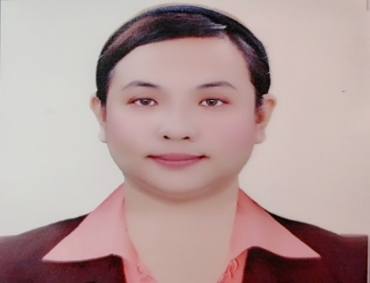
CHERRY ANN D. BARTOLOME,RN
Contact#:09357072539
E-mailAddress:anne23.bart@gmail.com
Address:374 Valencia Street Sta. Mesa Manila, Philippines

OBJECTIVE:
To land on a challenging job where I can fully
dedicate my profession, apply and enhance my
experience, and provide ample room for professional
growth and financial satisfaction.

PERSONAL DATA:
DATE OF BIRTH: August23,1986
AGE: 35y/o
CIVIL STATUS: Single
PLACE OF BIRTH: Amulung, Cagayan Valley, Philippines
NATIONALITY: Filipino
HEIGHT: 5’2”
WEIGHT: 80KGS

RELEVANT EXPERIENCE:
Company: Carelink Healthcare Services and Co.
Position: Private Duty Nurse
Date: June 2013 up to March 2020

Company: De Ocampo Memorial Medical Center
Position: Staff Nurse
Date: February 1,2021 up to Present

EDUCATIONAL BACKGROUND:
TERTIARY: De Ocampo Memorial College
Sta.Mesa Manila
2003-2007
SECONDARY: Cagayan National High School
Tuguegarao City,Cagayan Valley
1998-2002
ELEMENTARY: Caratacat,Elementary School
Caratacat, Amulung,Cagayan Valley
1992-1998

RELATED LEARNING EXPERIENCE:
CAGAYAN VALLEY MEDICAL CENTER,Tuguegarao City,Cagayan Valley
HOLY INFANT CLINIC,Tuguegarao City,Cagayan Valley
LUNG CENTER OF THE PHILIPPINES,Quezon City,Philippines
DE OCAMPO MEMORIAL MEDICAL CENTER,Sta.Mesa, Manila Philippines
NATIONAL CHILDRENS HOSPITAL,Quezon City,Philippines
APRIL 2005-MARCH 2007

TRAINING:
3-Day Intravenous THERAPY TRAINING UPDATE
JULY 24-262016
CAPITOL MEDICAL CENTER

BASIC LIFE SUPPORT
(ADULT CPR TRAINING FOR LAY RESCUERS)
Philippine National Red Cross Manila Chapter
June23,2006

FIRST AID TRAINING
Philippine National Red Cross Manila Chapter
June 19-22,2006

3-DAY BASIC INTRAVENOUS THERAPY TRAINING
Cagayan Valley Medical Center,Tuguegarao City
February22-24,2011

CHARACTER REFFERENCES:
Milagrina C. Quilang TeacherIII
Caratacat Elementary School
Dep-Ed,Amulung West, Cagayan Valley, Philippines
+63917-918-3880

MaricrisR.Mendoza Nurse
Carelink Health Services and Co.
I hereby dispose and say that the above information are true and correct to the best of
my knowledge and belief.

CHERRY ANN D. BARTOLOME,RN
SIGNATURE OVER PRINTED NAME

