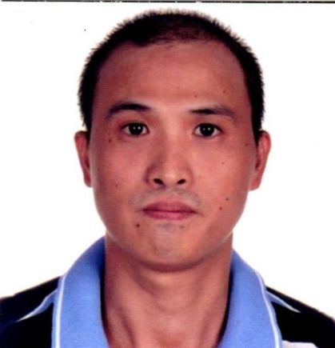
MACHINE OPERATOR
DINDO G. SANSANO
Sinapangan Sur, Balaoan, La Union
Contact No.: 09563921491
Email add.: dindosansano90@yahoo.com
Passport No. :P2224766B
PERSONAL DATA

Date of Birth : October 24, 1981
Place of Birth : Tuba Benguet
Gender : Male
Civil Status : Married
Citizenship : Filipino
Height : 165cm.
Weight : 60kgs.
Father’s Name : Warlito Sansano
Mother’s Name : Rebecca Sansano
Spouse Name : Olympia Sansano
Language Spoken : Ilocano, Tagalog, English
Person to be notified in case of emergency
: Olympia A. Sansano
09156671016
EDUCATIONAL ATTAINMENT

Secondary : Sinapangan National High School
1998-1999
Primary : Sinapangan Sur Elementary School
1994-1995
WORKING EXPERIENCE

July 2013-July 2015 Taegosaneop (South Korea)
Machine Operator
May 2010-August 2012 DTR Yangsan (South Korea)
Machine Operator
November 2007-April 2010 Sejinsanyeb (South Korea)
Machine Operator

I hereby that the above information is true and correct to the best of my knowledge and belief.

DINDO G. SANSANO

