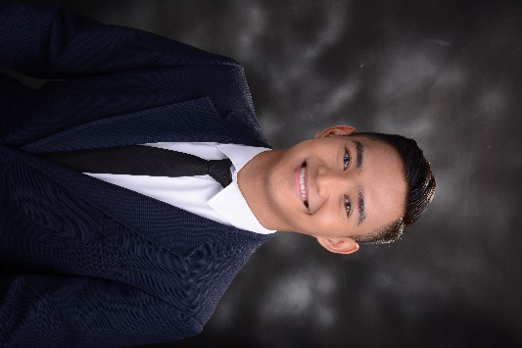    (0906) 478 8744    migeealfaro@yahoo.com  061 San Jose Patag Sta. Maria, Bulacan  April 8, 1998  OBJECTIVE  To obtain a position where I can utilize my skills and gain further experience while growing personally and excel professionally. | MIGEE ANDREW H. ALFARO  EDUCATION  STA. MARIA ELEMENTARY SCHOOL (2006-2011)  SACRED HEART ACADEMY OF BULACAN (2011-2015)  BULACAN STATE UNIVERSITY (2015 – 2019)  Bachelor of Science in Environmental Science  City of Malolos, Bulacan  WORK RELATED EXPERIENCE  ENVIRONMENTAL MANAGEMENT SPECIALIST (EMS) AT DENR, PENRO, BULACAN  Under the Department of Environmental Management Unit & Manila Bay Rehabilitation Project  (September 2, 2019 up to present)  Okasyon the Events Specialist  Part time event coordinator  (December 1, 2018 to August, 2019)  SEMINARS AND WORKSHOPS  - ASEAN Campus Forum: Partnering for Change, Engaging the World  Bulacan State University; City of Malolos, Bulacan  September 21, 2017  - Environmental Toxicology: Unraveling the Mystery Behind Toxicants  Bulacan State University; City of Malolos, Bulacan  March 16, 2018  - Climate Change (April 27, 2016)  Bulacan State University; City of Malolos, Bulacan  April 17, 2016  - Internship Orientation Seminar  Bulacan State University; City of Malolos,  Bulacan  April 25, 2018  - World Wetlands Day Symposium  Facilitated by BulSU-Institute of Environmental Governance and Wetlands International Philippines  February 2019  - Geographical Information System Trainig  Citta De Oro, Sta. Rita, Guiguinto, Bulacan  TECHNICAL SKILLS AND QUALIFICATIONS  - Reliable and fast learner  - Above average computer skills on relevant applications  - Highly flexible and adaptive  - Responsible and accountable  - Good communication skills  - Passionate and dedicated with work  CHARACTER REFERENCES  - OFELIA S. CONAG  OIC, Technical Service Division  DENR, PENRO BULACAN  0917-962-0740  - APRIL-LYN E. NAVARRO  MB STAFF  DENR, PENRO BULACAN  0967-218-0492  The above statements are true and correct to the best of my knowledge and ability.  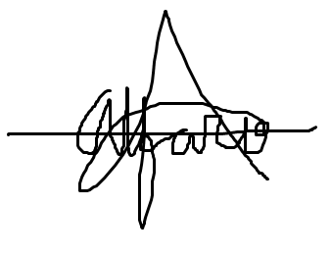  Migee Andrew H. Alfaro

