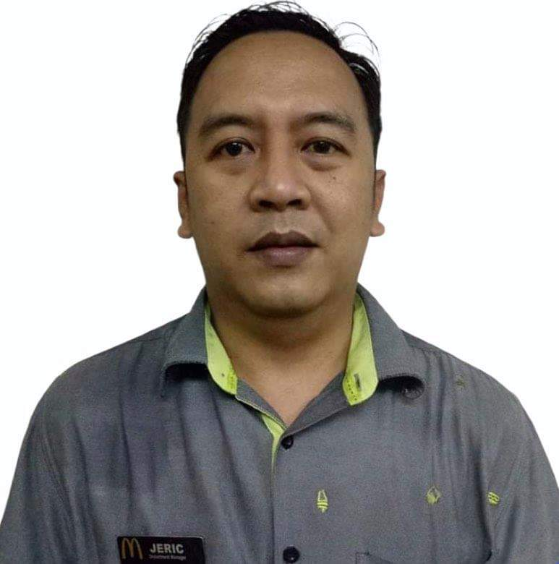

Attach Here
2x2
Colored Picture
Jerico B. Dalawis
37- G Scout Borromeo St., Brgy South Triangle
Quezon, city
Mobile No.: 09238703566
Email Add: jericdalawis@gmail.com

Work Experiences:

DEPARTMENT MANAGER:

June 1,2018 - Present
Golden Arches Development Corporation (McDonald’s Philippines)
17th Floor, Citibank Tower Paseo de Roxas, Makati City
Tel No. 8888-500

Duties and Responsibilities:

- Demonstrates and reinforces the leadership behaviors and basic
people minimums ( uniform, crew schedules etc.) necessary to
gain commitment from crew and leadership
- Schedules, plans and conducts crew meetings, events and rap
Sessions
- Conducts Crew Trainer meetings at least monthly
- Develops training/SOC schedule for new and existing employees
and post weekly
- Complies with restaurant safety action plans
- Maintains records for safety and appropriately documents
contributions and performance in personnel file.
- Ensures Department members adopt correct food safety
proceduresTrains Crews and Managers on cleanliness tasks for the
department
- Performs assigned daily, weekly and monthly equipment
Calibration
- Ensures labor controls are completed hourly (by Shift Managers)
- Ensures daily labor is within projections
- Identifies danger zones; diagnoses and provides direction and
Coaching
- Maintains and adjusts positioning according to positioning guide
- Conducts follow up on primary and secondary duties of crew and
managers

SHIFT MANAGER:

January 1, 2014 – June 1, 2018
Golden Arches Development Corporation (McDonald’s Philippines)
17th Floor, Citibank Tower Paseo de Roxas, Makati City
Tel No. 8888-500

Duties and Responsibilities:

- Completes and verifies Food Safety Daily Checklist (FSDC)
- Monitors food safety procedures during the shift
- Communicates with previous and subsequent Shift Manager and identify
sales trends and opportunities
- Communicates shift targets and goals to all team members
- Monitors and communicates progress toward targets throughout the shift
and energize the team to meet them
- Maintains stock levels
- Receives products by checking order accuracy, quality, and condition
- Tracks and counts raw and completed waste on each shift
- Demonstrates and reinforces the leadership behaviors and basic people
minimums (uniform, crew schedules, etc.) necessary to gain commitment
- from crew and leadership.
- Executes a plan, based on an employee commitment measurement, to
increase employee’s loyalty satisfaction and pride with the McDonald’s
experience.
- Ensures Crew and personal appearance standards are met
- Verifies completion of or follow-up on cleaning tasks
- Verifies completion of or follow-up on planned maintenance tasks
- Monitors and trains Crews to correct production procedures
- Monitors and trains Crews to correct service procedures
- Follows customer recovery process when necessary
- Maintains first aid qualifications and properly implement procedures
- Applies restaurant safety and security processes
- Ensures that labor controls are in place each hour and each shift
- Monitors and conducts follow up on SOC completion
- Delivers outstanding QSC & V as measured by achieving a zero CSO
Standard.

SERVICE CREW:

February 12, 2004- January 1, 2014
Golden Arches Development Corporation (McDonald’s Philippines)
17th Floor, Citibank Tower Paseo de Roxas, Makati City
Tel No. 8888-500

Duties and Responsibilities:

- Delivers outstanding quality product.
- Ensure Food Safety minimums in placed in the kitchen area.
- Directly reported to Kitchen Manager and head crew.
- Conduct Inventory of products during closing time.
- Ensure cleanliness of the kitchen areas.

TRAININGS & SEMINARS:

Effective Management Practice Course
October 2015
3rd Floor, F&M Lopez II Building
109 Carlos Palanca Street, Legaspi Village, Makati City

Advanced Shift Management Course
February 2015
3rd Floor, F&M Lopez II Building
109 Carlos Palanca Street, Legaspi Village, Makati City

Shift Management Course
November 2014
3rd Floor, F&M Lopez II Building
109 Carlos Palanca Street, Legaspi Village, Makati City

EDUCATION:

COLLEGE : June 2002- June 2004
:. Bachelor in Science in Custom Administration
: Philippine Maritime Institute : Roosevelt Avenue Quezon City, Philippines

HIGH SCHOOL : June 1998- April 2002
: Trinity University of Asia : Eugenio Rodriquez Quezon City, Philippines

ELEMENTARY : June 1993 – April 1998
: Kamuning Elementary School
: Scout Torillo St. Quezon City, Philippines

