




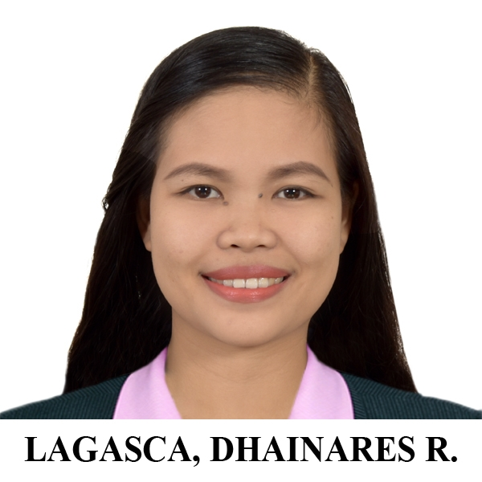



SKILLS
- Adaptability and Flexibility
- Good Communication Skills
- Computer Skills
- Initiative
- Multi-tasking
- Problem Solving Abilities
HOBBIES
LANGUAGES
TAGALOG

ENGLISH

ILOCANO

CERTIFICATIONS
License Professional Teacher December 2019
120-Hour TESOL Certificate Course May, 2020
EXPERIENCE
Substitute Teacher May 2021-August 2021
Tayug National High School
- Guiding the students in modular approach of learning by monitoring them through the use of cellular communication.
- Conduct a home-visit to the students who are not submitting modules and not updating for a long period of time.
Junior and Senior High School Teacher April 2018-May 2021
Luna Colleges
- Create a student-centered lesson plan.
- Assess students to evaluate their abilities, strengths, and weaknesses and to provide them feedback.
Student Assistant (Admin Clerk) June 2016-March 2018
Luna Colleges- Registrar’s Office
- Organize and administer records of college and Master of Arts students.
- Assist and process professors and staff request.
- Interacting with students via email and phone, addressing any questions or concerns.
EDUCATION
ELEMENTARY 2004-2010
Calapugan Elementary School
Natividad, Pangasinan

SECONDARY 2010-2014
Natividad Oriental Academy
Natividad, Pangasinan

TERTIARY 2014-2018
Bachelor of Secondary Education major in English
Luna Colleges
Tayug, Pangasinan

Highly motivated and dedicated individual ssearching for suitable opportunities that will utilize my knowledge, skills and extensive education and to help me grow personally and professionally.
CAREER OBJECTIVES
https://www.facebook.com/dhainares.rafael/
LAGASCA, DHAINARES R.
0961-041-8200
dhainalagasca18@gmail.com
Purok 2, Brgy. Calapugan Natividad, Pangasinan
CONTACT

