CURRICULUM VITAE (CV)
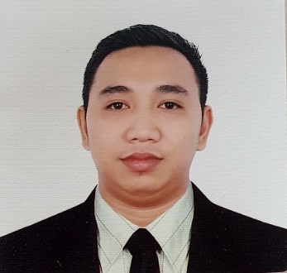
Roger Jr. M. Encarnacion
2872 E Limay St. Tondo, Manila
Contact No.+639672117771
Email Address: encarancion.roger01@gmail.com

CAREER OBJECTIVE

- To be able to work in a well established company that, I can enhance my knowledge and improve my skills.
- Seeking an opportunity from a leading and reputable organization that will lead to a long-term career relationship

CAREER HISTORY

- University of the Philippines ( UP Diliman Quezon City )
Senior Office Assistant (Accounting Office)
August 2, 2021 – November 2, 2021

- E. Rodriguez Jr. High School (Schools Division Office of Quezon City)
Office Clerk (Accounting Office)
January 3, 2019 – December 31, 2020

- Amwaj Catering Services (QATAR)
Customer Services Assistant / Barista
November 8, 2017 – November 11, 2018

- E. Rodriguez Jr. High School (Schools Division Office of Quezon City)
Office Clerk (Accounting Office)
January 8, 2014 – June 30, 2017

- Madarin Sky│ Seafood Restaurant ( 61 Simoun St. Brgy. Sto Domingo, QC)
Waiter
February 15, 2013 – July 5, 2013

EDUCATION ATTAINMENT

College: : Informatics College of Caloocan (under grad 1st year BSIT)

High School: : F.G. Calderon Integrated School (2006-2010)

Elementary: : F.G. Calderon Integrated School (2000-2006)

SPECIAL SKILLS

- Computer Literate
- Driving
- DUPLO RISO operator

SEMINAR TRAINING ATTENDED

- Roll Our of Unified Reporting System V2.0 and Preparation of CY 2019 Year End Financial and Budgetary Reports.
December 16-18, 2019 at Le Charme Suites, Subic Zambales

- 2019 Brigada Eskwela “Matatag na Bayan para sa Maunlad na Paaralan
May 20-25, 2019 at E.Rodriguez Jr. High School

- In-Service Training for Teachers and Non-Teaching personnel
May 25-27, 2017 at E. Rodriguez Jr. High School

- In-Service Training for Teachers and Non-Teaching personnel
October 25-27, 2016 at E. Rodriguez Jr. High School

- DCP Batch 37 Lot 1 Training program for Schools ICTO’s and Classroom Teachers
September 6, 2016 at E. Rodriguez Jr. High School

- In-Service Training for Teachers and Non-Teaching personnel
October 27-29, 2015 at E. Rodriguez Jr. High School

- Social Media, Networking & Netiquette Smart Community Care Trainings
October 25, 2012 at Informatics College of Manila Campus, Recto Manila

- Resume Writing, Interview Tips and Power Personality Trainings
October 14, 2011 Organized by Smart Communications and Informatics College Manila

- Emotional Quotient & Customer Service 101 Trainings
October 14, 2011 Organized by Smart Communications and Informatics College Manila

- Systems Seminar
August 5, 2011 at Fujitsu Ten Solutions Inc. Philippine Stock Exchange, Ortigas Pasig

PERSONAL INFORMATION

Nick Name : Roger
Age : 27
Birthday : May 1, 1994
Birth Place : Manila
Nationality : Filipino
Religion : Roman Catholic
Height : 165 cm.
Weight : 67 kg.
Language Spoken : English and Tagalog

I certify that all of the above information are true and correct.

Roger Jr. M. Encarnacion
Applicant

