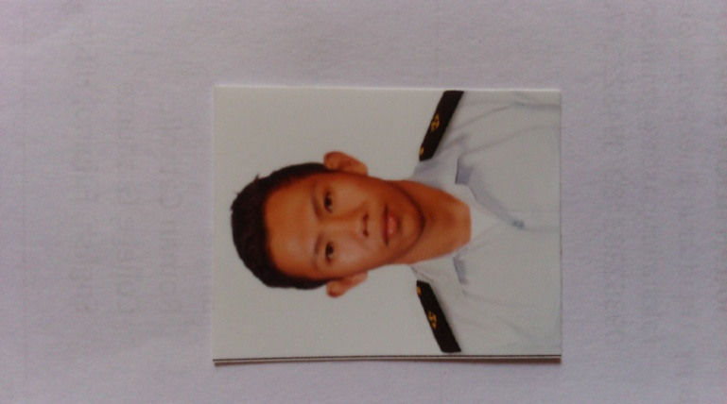
RALPH ALJON S. PASCO
Brgy. Tinadtaran Buenavista Guimaras
ralphaljonp@gmail.com
09352393480

PERSONAL INFORMATION

Age: 26
Date of Birth: October 25, 1993
Height: 5’8’’
Civil Status: Single
Religion: Roman Catholic
Occupation: Seafarer
Language Spoken: English, Filipino, Hiligaynon

SUMMARY OF QUALIFICATIONS AND TECHNICAL SKILLS

- Knowledgeable in Navigational Watch
- Knowledge in navigational equipments
- Experienced in performing Deck works
- Able to work with less supervision
- Experienced in offshore vessels
- Can work with different nationality

EDUCATIONAL BACKGROUND

- Tertiary
John B. Lacson Foundation Maritime University 2010 to 2013
“Bachelor of Science in Marine Transportation”

- Secondary
Colegio Del Sagrado Corazon De Jesus, Gen.Hughes St.Iloilo City 2006 to 2010

- Primary
Buenavista Seventh-Day Adventist Mclain Buenavista Guimaras 2000 to 2006

Certificates

- BASIC SAFETY TRAINING
- MARPOL 73/78
- INTERNATIONAL SAFETY MANAGEMENT
- PREVENTION OF ALCOHOL AND DRUG ABUSE IN THE MARITIME SECTOR
- PROFICIENCY IN SURVIVAL CRAFT AND RESCUE
- SHIP SECURITY AWARENESS TRAINING AND SEAFARERS WITH DESIGNATED SECURITY DUTIES
- H2S AND SCBA FAMILIARIZATION TRAINING
- RATINGS FORMING PART OF NAVIGATIONAL WATCH
- MARITIME ENGLISH

_____________________________________________________________
SEMINARS ATTENDED

“Ships Familiarization”
2go Shipping Philippines

“On Board Vessel at jwest shipping lines”
Cebu City Philippines
2014-2015

______________________________________________________________________________
EXPERIENCE

On Board Zamil Offshore
Saudi Arabia
2017-2019
______________________________________________________________________________
REFERENCE

EMILY V. VALDE
OPERATIONS MANAGER
SUNBRIGHT MARITIME SERVICES INC
Contact No. +639173149671
+639993604947

SALVACION V. LOSBANESPRESIDENT/CEO
SUNBRIGHT MARITIME SERVICES INC
Contact No. +639185651187
+639323282110

