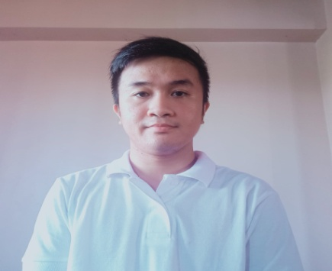
ALWYN A. PANEDA
16H Antonio st. Rincon Valenzuela city
09162098806
qpaneda@yahoo.com

OBJECTIVES : To be associated to a company that will provide opportunities for my
Development.

QUALIFICATION :

MACHINING NCII
Issued on : October 28, 2020
Valid Until : October 27, 2025

SHIELDED METAL ARC WELDING NCII
Issued on : July 29, 2016
Valid Until : July 28,2021

EDUCATION :

Vocational
MACHINING NC ll
Don Bosco TVET Center
Tondo, Manila
S.Y. November 2014 – March 2016

College (Undergraduate)

Sea Fairer’s Rating Course (SRC)
Our Lady Of Fatima University
#120 McArthur Highway, Valenzuela City
S.Y. June 2013 – March 2014

Secondary
Children Of Mary immaculate College
#22 MaysanRoad.,Malinta, Valenzuela City
S.Y. June 2009 – March 2013

ACHIEVEMENTS/AWARDS :

Certificate of Conduct Award (Don Bosco Youth Center Tondo)
Certificate of Excellence in Attendance (Don Bosco Youth Center Tondo)
Certificate of Completion BAKING COURSE (Ugnayan Migrant Workers/Taipei,Taiwan)
Certificate of Completion PHOTOGRAPHY (Ugnayan Migrant Workers/Taipei,Taiwan)

AFFILIATION :

Sacristan - San Isidro Labrador Parish (2015-2017)

SKILLS :

Ability to read micro meter and Vernier Caliper
Basic blueprint reading
Operate Conventional Lathe machine , milling machine and basic welding
Ability to think a head, anticipate problems, make decisions.
Experienced in set up operation of CNC Notching

PERSONAL DATA :

Age : 23 years old
Date of birth : December 03, 1996
Place of birth : Valenzuela City
Civil status : Single
Citizenship : Filipino
Religion : Roman Catholic
Height : 5’2
Weight : 55 kg
Contact no. : 09162098806

WORKING EXPERIENCE :

YEE FING MACHINERY CO., LTD

No.24, Ln. 216, Yong Feng Rd., Bade Dist., Taoyuan City., Taiwan.

APRIL 04, 2017 to APRIL 04, 2020 ( 3 YEARS )

FACTORY WORKER / MACHINIST

Maintain clean, neat, and organized work area
Used safety glass before operate machine
Analyzed and followed blueprints and drawing
Followed all standard operations procedures and safety guidelines
Operate lathe machine, milling machine , CNC notching and Grind cutter

REFERENCES :

LEE SHIH TSUNG (EMPLOYER)
Contact no. : 03-3610586

STERLING TEEL INCORPORATED

81 R. DELPIN ST., MARULAS, VALENZUELA CITY, PHILS.
TEL. NOS: (632) 291-6767, 291-6769, 291-6771 FAX: (632) 291-6797
P .O. BOX 1076 MANILA , PHILIPPINES EMAIL:SSISSI@i-manila.com.ph

NOVEMBER 06, 2015 - APRIL 15, 2016 (on-the-job-training / 5 MONTHS)

APRIL 19, 2016 - SEPTEMBER 26, 2016 ( 5MONTHS)

FACTORY WORKER / MACHINIST

Perform quality control check and verification of work order specification
Work safety in the manufacturing production
Performing inspection of product to ensure that it meets quality standards
Operate conventional lathe and milling machine

REFERENCES :

MARIETA B. BARCELONA (O.I.C/Personal)
Contact no. : 291-6767

