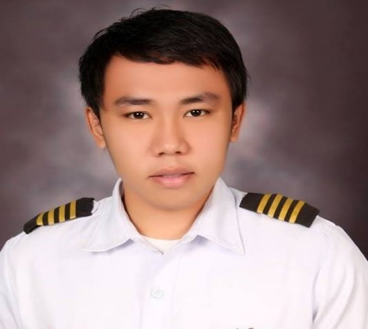
de la Cruz, Gimel Kyrl N.
Contact number: PH no.:+639672032794
Address: Impress, Ceres football field, Ayala North,
Talisay City, Negros Occidental.
Email address: gkdelacruz07@gmail.com

Summary of Qualifications:

- Has high energy and dependable individual who excels in challenging and fast paced environment.
- Can handle high-pressure situations in a professional and effective manner.
- Good communication skills and computer literate.
- Can work with less supervision and a good team player.
- Polite, respectful, and courteous manners.
- Resourceful and self-confident; can get the job done, and do it well.

Related Experiences:
Rolls-Royce Singapore Pte. Ltd.
1 Selatar Aerospace Cresent
Engine Technician (TRENT 1000-10 and 7000) from January 2020 to August 2020(retrenched).
- Certifying stamp holder for Trent 1000-10 and Trent 7000 WS3-WS6.
- Vertical Core Assembly and Strip of Trent 1000-10 and Trent 7000.
- WingBif assembly for Trent 1000-10 and Trent 7000.
- Issued License to Operate Technical Instructions by Rolls-Royce.

Singapore Aero Engines Services Pte Ltd
Subcontracted by AJI (Aviation Jobs International)
11 Calshot Rd, Singapore 509932
Engine Technician (TRENT 700, 900 and 1000) from August 2019 to January 2020(resigned and transferred to Rolls-Royce).
- Performed IP Compressor case build and strip.
- Performed FBH (Front Bearing Housing) build and strip.
- Performed IP Compressor to FBH stack (final assembly).
- Performed IP Compressor rotor build up.
- Performed IP Compressor rotor balancing.
- Performed FBH airflow check for sign of leakage.

Saudia Aerospace Engineering Industries
Subcontracted by El Khereiji Contracting Company
Jeddah, Saudi Arabia
Aircraft Power Plant Technician (A320/A321- CFM56-b) from December 2016 up to January 2019.
- Performed Engine changed on aircraft A320A/321 (CFM56-B).
- Performed R&R engine component as per TSV and AMM.
- Performed A-check package.
- Removal/installation of movable, fixed fairings and pylon drains as per TSV and AMM in accordance with Saudia Airlines EO.
- Performed R&R of Thrust Reverse cowl and Fan cowl with the use of proper tooling and equipment in accordance with AMM.
- Performed Air Inlet Cowl removal and installation with the use of proper tooling and
equipment in accordance with AMM.
- Performed and observe proper aircraft tooling and equipment to carry out the required inspection, servicing and maintenance in compliance with the specification and quality control standard.
- Wheels and Brakes removal/installation.
- Hydraulic Systems servicing, maintenance and operation checks.
- Knowledgeable of AMOS and Airnav Softwares.

Jet Propulsion Center- SAUDIA AIRLINES
- Assist in strip/overhaul of CFM56-B core as per Engineering Order and EMM.
- Assist in build-up/installation of engine components, air bleed ducts, fuel line tubes, hydraulic line tubes, brackets, mounts as per EMM.

DOTA Aero Aviation Services
Bldg. 1 Unit 6A Salem Complex, Pasay city
Cabin Maintenance Trainee from Sept. 2015 up to March 2016
Maintenance Service Provider of Cebu Pacific Air (Line Maintenance).
- Have experience on A320 and A319 Cabin Maintenance.
- Have experience on Geven, Weber and Sicma Aero Seats respectively.
- Remove and install damage/inoperative parts on Geven, Weber and Sicma aero seats.
- Perform Cabin Sweep Checks on seats, galleys and lavatories of A320 and A319.

License Authority:

- Airframe and Power plant Rating
License no. 128317-AMT
Civil Aviation Authority of the Philippines
Issued date: 22 April 2019

Personal Data:

Age : 28 years old
Gender : Male
Status : Single
Birthdate : July 7, 1993
Birthplace : Bacolod City
Height : 5’5’’
Weight : 132 lbs.
Religion : Roman Catholic
Nationality : Filipino
Language : English, Filipino, Arabic

Educational Background:

College: Philippine State College of Aeronautics
Bachelor of Science in Aircraft Maintenance Technology Mactan Benito-Ebuen Airbase, Lapu-Lapu City, Cebu
SY: 2010-2014

High School: Colegio San Agustin-Bacolod
Bacolod City
SY: 2006-2010

Elementary: Bacuyangan Elementary School Hinoba-an, Negros Occidental
SY: 2000-2006

SEMINARS ATTENDED:

Trent 1000 Lvl 1 (General Familiarization)
Trent XWB General Familiarization (CBT)
Aerospace Inspection for Gas Turbine Businesses
Air Cargo Security - Level A
Basic Environmental Principles for Off Site Workers.
Basic Lifting Operations Safety for Off-Site Workers
Basic Lifting
Basic Risks
Calibration
CLE Licence to operate
Component Proving and FAIR
Compressed Air for Rolls-Royce Operators
Control of Non-Conformance
Display Screen Equipment (DSE) – Managing your Comfort
Environmental Awareness and Resource Efficiency
GP EP 3.2.4 Verify Production Method – Awareness
GP SP 3 Produce Product Awareness
GP SP 4 Verify Produced Product Awareness
Handling Essentials
Hazardous Substances
Health Safety and Environment (HS&E) and Occupational Health (OH) for all
Human Factors
Improvement Activity Confirmation
Introduction to Personal Protective Equipment
Introduction to Problem Solving
Level of Control Applied to Engine Components
Living our values
Manual Handling Techniques
Manufacturing and Inspection Documents
Procedural Declaration
Quality Procedures and Instructions
Responsibilities of Stamp Holders
Security Awareness
Slips Trips and Falls
Technical Instruction Assessment - S2-10 FOD
Vision Testing
General Familiarization of Airbus 320
PCAR Part 5 Airworthiness
Airbus 320 Aircraft Maintenance System Management
Seminar on Gender and Development for the Young Generation
Communication and Navigation
Introduction to Advance Composite Structure

