RESUME
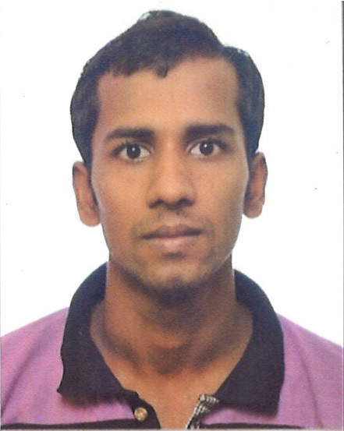
RASEL AHMED
No.2 Pioneer Sector Walk Singapore.627828
Phone number: +6582426928

CAREER OBJECTIVE

To be able to land a promising career related to Welder Fabricater / Fitter, where acquired knowledge and experience will be fully utilized and applied.

PERSONAL STATEMENT
Father’s Name :Md. Abul Kalam Mazi
Date of Birth :20/10/1989
Sex :Male
Marital Status :Un-Married
Languages known :To Speek : Bangla & English
Read & Write :Bangla & English
Nationality :Bangladeshi
Religion :Islam.
Permanent adders :Babutipara (vill)
Eillotgonj (post office)
Muradnagar (police station)
Comilla (dist)
Bangladesh
Present adderss : Hoo Huat Engineering Pte Ltd.( Dormitory)
No.2 pioneer Sector Walk
Singapore 627828

PASSPORT DETAILS: -
Passport No (Old) : BB0724263
Passport No ( New ) : BW0161213
Date of Issue : 21 July 2018
Date of Expiry : 20 July 2023 Place of Issue : Dhaka
Work permit/Fin No : 063435589/G6834694R

PROFESSIONAL SKILLS
- Reading and interpreting drawings and plans;
- Working with a wide variety of heavy transport products with steel using MIG welding.
- Operating welding equipment;
- MIG solid wire, MIG flux cored wire;
- SMAW Electrodes ;
- Pipe welding (FCAW & SMAW) ;
- Cutting, Auto Cutting ,Fitting & Gouging .
- Assembling large and small Steel metal Shipyard ;
- Experience and knowledge of Marine heavy industry, including heavy Steel fabrication Metal Components to Assemble Structural work ;
- Understanding all kind of dimension to work with the following job description;
- Understanding CAD drawings;
- Experience with Forklift Driver ;
CERTIFICATES AND TRAINING
- FCAW/MIG welding ( MILD STEEL) ALL POSITION;
- SMAW/ Electrode welding ( MILD STEEL) ALL POSITION;
- Professional supervisory course .
- Shipyard Safety Instruction Course .
- Shipyard Safety Instruction Hot work Course .
- Shipyard Safety Supervisor Course .
WORKING EXPERIENCE
- Almost eighteen (11) years (Singapore 2011- Present, ) of extensive experience in hull fabrication, welding practices and involving quality control with emphasis on inspection of various steel structures Working in Shipyard , Oil and gas Tank, power generation(B383) , petrochemical project. [(Ensco NO 120-121) Maersk Drilling Company, TS Drilling Company & etc.]

I would like to contribute to organization’s goal and objectives which combine the skills of hands-on and technical knowledge and strong work ethics .To encourage the value of efficiency, productivity, commitment and dedication to service.

WORK HISTORY: 11 years
HDS OFFSHORE & ENG.PTE LTD  Location  Period employed | - Fabricator & Welding In Charge  - Singapore (Keppel FELS)  - 03/10/2017 to till Present
Duties:
I'm working in heavy Marine Sector. Currently, our project in Singapore Keppel FELS Shipyard Metal Components to Assemble Structural Welding and fabricator In-charge,

- Ensure that before welding start, check and review the approved Issued for Construction (IFC) drawing if correct welding joint follow.
- Prepare the necessary tools like welding machine, filler rod, electrode to be use as per approved WPS.
- Check for the welding machine voltage and current, how much current to supply during while the welding is on-going.
- Ensure that fit-up, degree of bevel, hi-lo and gap are according to approved WPS (Welding Procedure Specification).
- To ensure and follow the procedure if pre-heating is required for the welding joint, how much heat is required before can proceed welding.
- To familiarize and ensure low hydrogen electrode heating schedule such as E7016, E7018 like baking up to 300 degrees for one hour and holding for 150 degrees continues.
- To ensure that job is acceptable in terms of quality by following correct and approved procedure with the application of International Standards and ASME Codes.

- Company : SEAH MARINE ENG.PTE LTD
Position : Welder /Fabricator
Duration : 02/03.2011-04/11/12
- Company : WRYTE MARINE ENG. PTE LTD
Position : Welder /Fabricator
Duration : 05/11/ 12 - 02/10/ 17
- Company : HDS OFFSHORE & ENG.PTE LTD
Position : Fabricator & Welding In-Charge
Duration : 03/10/2017 to till Present

EDUCATION QUALIFICATION
- Keron Khal High School  Location  Period of study |  | - S.S.C (Secondary School Certificate) 2007  - Certificate from Comilla board of education , Bangladesh  - 2004-2006
 | - Chandina Redawan Ahmed Collage  Location  Period of study | - H.S.C (Higher Secondary Certificate) 2010  - Certificate from Comilla board of education, Bangladesh  - 2007-2010

COMPUTER SKILLS
- Windows Application & Internet;
- Microsoft Word;
- Microsoft Excel;
- Microsoft Access
Employment training certificates available on request.
Referees TBA
