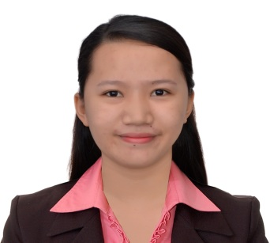
FERLEEH DYN AGTANG DACANAY

Brgy. Dampig, Pagudpud, Ilocos Norte
2919 Philippines
ferleehdyn.dacanay@gmail.com
+966540287384

CAREER OBJECTIVES

To pursue opportunity which will allow me to grow professionally, while effectively utilizing my versatile skills to help achieve institution's vision, mission, goals and objectives. And acquire further enhancement of my knowledge, nursing skills and values in providing safe and quality patient care.

PERSONAL INFORMATION

Age : 24 years old
Date of Birth : August 25, 1996
Place of Birth : Bangui District Hospital
Citizenship : Filipino
Civil Status : Single
Religion : Pentecost
Height : 159 cm
Weight : 53 kg
Languages : English, Tagalog

EDUCATIONAL ATTAINMENT

Tertiary Education
Mariano Marcos State University
Bachelor of Science in Nursing
City of Batac, Ilocos Norte
June 2017

Secondary Education
Lanao National High School
Bangui, Ilocos Norte
April 2013

Elementary Education
Pias-Gaang Elementary School
Currimao, Ilocos Norte
March 2009

ELIGIBILITY

Registered Nurse
Professional Regulation Commission
License No: 0902111
January 2018

Nurse Technician
Saudi Commission for Health Specialties
License No: 19117394
February 2020

SEMINARS AND TRAININGS ATTENDED

Basic Life Support
American Heart Association
Al Olaya, Riyadh, Saudi Arabia
October 2019

Cardio Pulmonary Resuscitation
Asian Hospital and Medical Center
Alabang, Muntinlupa City
April 2018

Basic EKG Interpretation
Asian Hospital and Medical Center
Alabang, Muntinlupa City
May 2018

Intravenous Therapy
Asian Hospital and Medical Center
Alabang, Muntinlupa City
May 2018

WORKING EXPERIENCES

Asian Hospital and Medical Center
Staff Nurse
Alabang, Muntinlupa City
April 2018 - September 2018

Capitol Medical Center
Staff Nurse
Quezon Ave. Cor, Sct Magbanua St. Quezon City
October 2018 - February 2019

Dr. Sulaiman Al Habib Hospital
Staff Nurse
Al Olaya, Riyadh, Saudi Arabia
August 2019 - September 2021

CHARACTER REFERENCES

Zhiela Marie Abiva
Instructor I
MMSU-College of Health Sciences
Batac City, Ilocos Norte
+639177223185

John Joseph Rieta
Assistant Manager - CEC
Asian Hospital and Medical Center
Alabang, Muntinlupa City
+639064592047

Daphne Peralta
Charge Nurse - Opthalmology Department
Dr. Sulaiman Al Habib Hospital
Al Olaya, Riyadh, Saudi Arabia
+966562043896

I hereby certify that the above information is true and correct to the best of my knowledge and skills.

Ferleeh Dyn A. Dacanay, R.N.
Applicant

