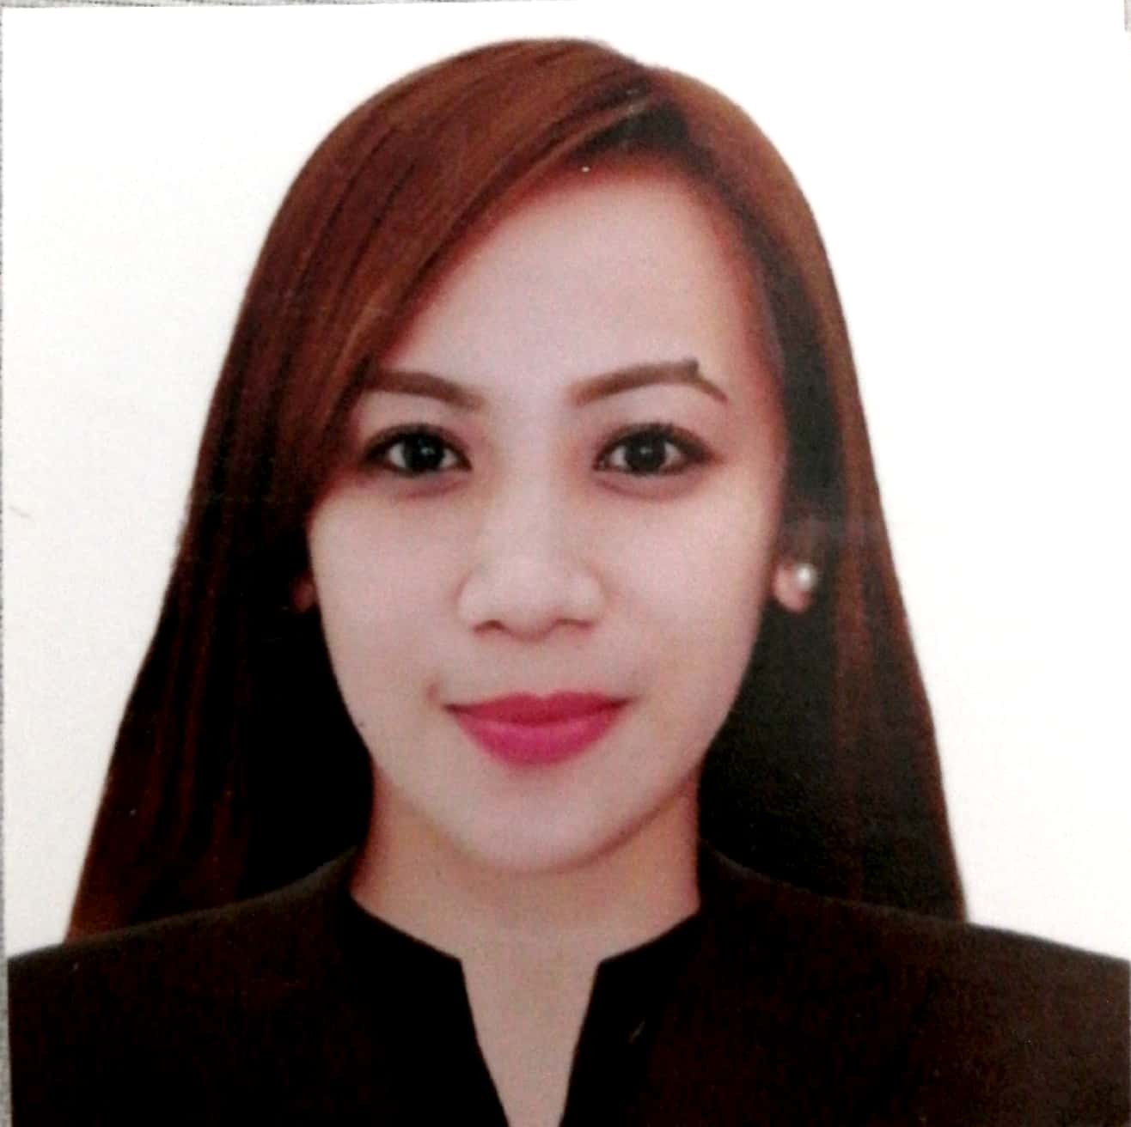
CHRISSALINE BENITO PASUMBAL, RN
Mobile # 0591231240
Email Address: mschrissaline@gmail.com

OBJECTIVE:
Compassionate and dedicated Registered Nurse seeking to leverage nursing experience and passion toward career in health care facility. Well-regarded skills in providing optimum patient care. Committed to continued professional training.

PROFESSIONAL EXPERIENCE:

Employment Dates: February 22, 2019 to Present
Employer: Dr. Baksh Hospital
Address: Al Sharafeyah District, Jeddah, Saudi Arabia
Position Held: Medical-Surgical Staff Nurse

Employment Dates: April 25, 2019 to October 31, 2019
Employer: Dr. Soliman Fakeeh Hospital
Address: Al Hamra Falesteen Street, Jeddah, Saudi Arabia
Position Held: Staff Nurse
Unit: Renal Dialysis Unit

Employment Dates: February 28, 2016 to April 24, 2019
Employer: Dr. Soliman Fakeeh Hospital
Address: Falesteen Street, Al Hamra, Jeddah, Saudi Arabia
Position Held: Staff Nurse
Unit: 5th Floor Building 1 Medical Unit

Employment Dates: December 11, 2013 – December 10, 2015
Employer: Prince Sultan Armed Forces Hospital, Al Madinah Al Munawarah, K.S.A.
Address: P.O. Box 15616, Al Madinah Al Munawarah, K.S.A.
Position Held: Medical-Surgical Staff Nurse
Unit/Ward: Medical-Surgical Ward

Employment Dates: November 18 2010 – August 18, 2013
Employer: Urdaneta Sacred Heart Hospital
Address: Mc Arthur Highway, San Vicente, Urdaneta City Philippines
Position Held: Medical Staff Nurse
Unit/Ward: VIP - Suite Unit

CORE COMPETENCIES:
- Solid clinical knowledge and good critical thinking skills.
- Provide care and information to patients to assist them in maintaining or improving their health.
- Sympathetic and caring to provide patients not only with the treatment they require but also with a soothing touch and kind words.
- Ability to keep personal information confidential.
- Exhibit compassion when caring for patients, understanding and sympathizing with their ailments and concerns.
- Ability to develop good working relationship.
- Remain calm and professional throughout critical incidents.
- Strong analytical skills, capable of assessing conditions and implementing appropriate intervention.
- Resourceful problem solver, capable of implementing solutions to complex problems.
- Possess special sensitivity to meeting diverse needs in varied situations.
- Develop rapport with patients, family, staff and physicians.
- Relate well to people from a variety of cultures.

DUTIES AND RESPONSIBILITIES:
- Prepares patient for admission, secures consent for hospitalization and management.
- Assists in execution of Cardiopulmonary Resuscitation in case of cardiac arrest.
- Assists patient who undergo examination procedures such as X-ray, Ultrasound, Echo, Duplex Scan, CT Scan, MRI, Transcranial Doppler Studies.
- Collects specimen such as urine, stool,sputum, extracts blood and bring them to the laboratory.
- Obtains information or data about the condition of the patient such as vital signs, history and physical examination.
- Promotes safety, mobility and hygiene, and give comfort to the patient.
- Monitors vital signs, measure fluid intake and output.
- Administered prescribed medications with the supervision of the staff nurse and report any symptoms and reactions.
- Answers nurse’s call, then immediately provided nursing care needed by the patient.
- Establishes, promotes and maintain good interpersonal relationships.
- Tidies patient’s room and do bed-making.
- Do nursing tasks such as carrying out doctor’s orders, changing the intravenous fluid, intravenous insertion, giving intravenous and oral medications.
- Do Tepid Sponge Bath to a patient who needs it continuously.
- Do oral care to the patient.
- Do stretching of linens.
- Observe or may assist special procedures in the ward that will be performed by the attending physician to his/her patient.
- Do perineal flushing, change diaper every shift or as needed.
- Do full bed bath to bedridden patients.
- Do blood transfusion, wound care, wound dressing and application of bandage, insertion of catheter, nasograstric tube, feeding and irrigation, administration of enemas, cystoclysis, colostomy care, tracheostomy and endotracheal tube care, suctioning (endotracheal and oropharyngeal), steam and oxygen inhalation, cardiopulmonary resuscitation, post mortem care.
- Do Respiratory Film Array/ MRSA swabbing for patients as ordered.

COMPUTER APPLICATION:
- Microsoft Word, Excel, Powerpoint
- Hospital Information and Management System (HIMS)
- OASIS
- Oracle
- Yassasi

EDUCATION:
Bachelor of Science in Nursing
Urdaneta City University
Batch 2007
Urdaneta City Pangasinan, Philippines

Registered Nurse License (Philippines) License Number: 0482756
Saudi Council Registration Number: 1 4-M-N-0013536

PERSONAL DATA

Home Address : #88 Ignacio Street Poblacion East, Asingan Pangasinan 2439 Philippines
Recent Address : Dr. Baksh Hospital Female Staff Accommodation, Al Sharafeyah, Jeddah, Saudi Arabia
Mobile Number : +966591231240
Email Address : mschrissaline@gmail.com
Nationality : Filipino
Religion : Christian
Date of Birth : December 25, 1986
Age : 35 years old
Marital Status : Single
Languages : English, Tagalog, Arabic

