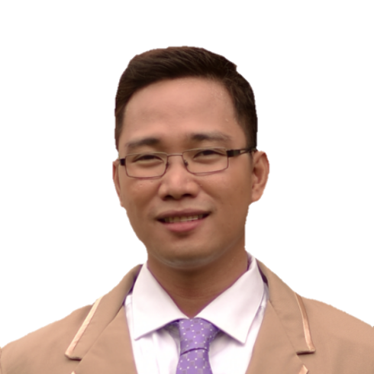

Your
2x2 picture
Here.

DORNATO D. ASEOCHE
Block 45 Lot 14, RC 7 Citrus CSJDM
Bulacan, Philippines 3023
Mobile No.: 0916-417-7912
Email Address: killua.zoldick21@gmail.com

- PERSONAL DATA:

Gender :Male
Age :32 yrs. old
Civil Status :Married
Date of Birth :April 21, 1988
Place of Birth :Paete, Laguna
Religion :Christian
Nationality :Filipino
Height :5’8”
Weight :75kgs
Name of Wife :Ma. Christina C. Aseoche
Contact Person :Ma. Christina C. Aseoche
Relationship :Wife
Contact No. :09277760165

- HIGHLIGHTS OF QUALIFICATIONS

* Registered Nurse with License No: 0521365, issued by the Professional Regulation Commission, Manila, Philippines

* Five (5) years experience in hospital setting

* Six (6) years experience in BPO industry

- EDUCATIONAL BACKGROUND

Tertiary Level: Far Eastern Univers
Nicanor Reyes St. Sampaloc, Manila, Philippines
Bachelor of Science in Nursing
2004-2008

Secondary Level: Eastern Laguna Colleges
J.P. Rizal St. Paete Laguna, Philippines
2000-2004

Primary Level: Paete Elementary School
Paete Laguna, Philippines
1994 - 2000

- EMPLOYMENT RECORD

Name of Employer : Skyline Hospital and Medical Center
Address : Skyline Dr. Cor. Quirino Hwy Brgy Tungkong Mangga CSJDM, Bulacan 3023,Philippines
Position : Staff Nurse
Unit/ Department : ER, General Ward
Nurse-Patient Ratio : 1:5-8
No. of Hours Rendered Per Week : 40 hrs
Inclusive Date : April 2016 up to present

Job Description:

Responsible for working under the direction and supervision of senior clinical
staff to deliver the very best in holistic nursing care to patients who are being
treated in the hospital. Performs overall registered nursing care and maintains optimum standards of nursing care and practice through assessment, planning, implementation, and evaluation of patient care.

Hospital: Skyline Hospital and Medical Center is a privately-owned secondary hospital with 100-bed capacity located at City of San Jose del Monte Bulacan. It envisioned to be the referral hospital north of Metro Manila with facilities and equipment that meets international standards.

Job Summary:
Provides professional nursing care in assigned unit. Performs frequent patient evaluations, including monitoring and tracking vital signs, performing procedures such as IV placement, and administering medications.
Specific Duties and Responsibilities:
- Emergency Room:
- Responsible for maintaining care standards in the emergency room
- Assist with checking in patients, doing triage work for doctors and generating initial insurance paperwork
- Part of the team who provided intensive emergency care and medical support in crisis situations.
- Performed patient intake of crisis and physical trauma cases, administering first response care and giving pain management medications
- Support and assist medical professionals, including surgeons, internists and various other treatment specialists
- Delivering high quality patient care which is clinically effective and evidence based.

2. General Ward
  - Provides nursing services including medications and injections as ordered by the doctor
  - Takes and record vital signs
  - Administer intravenous fluids
  - Administer oxygen if needed
  - Monitor and record urine and stool output
  - Collect specimen such as urine, stool and sputum as ordered
  - Observe changes in patient’s status or any untoward reactions and notifies the head nurse or doctor.
  - Secure results of laboratory test and other request
  - Assists patient in convalescence and rehabilitation.
  - Assist doctor during treatment.
  - Gives psychological reassurance to patient and relatives
  - Educates patient and families on proper care of the sick (identifies patient and family needs and concerns)
  - Develop and manage nursing care plan for the patient.
  - Participates in general and medical staff meeting as required
  - Participates in hospital and nursing activities and formal education programs.

EQUIPMENTS/ INSTRUMENTS HANDLED:
  - Standard Precaution (gloves, mask, aprons)
  - Stethoscope/ Blood Pressure cuff
  - Thermometers
  - Urinals, bed pan
  - Suction apparatus
  - infusion pump
  - suction machine
  - cardiac monitoring
  - ECG machine
  - defibrillator
  - glucometer

PROCEDURES ASSISTED:
  - Suctioning
  - Insertion of Naso-gastric tube
  - Wound dressing
  - IFC insertion
  - IV insertion
  - CBG monitorng

CASES HANDLED:
>Acute Gastroenteritis, Acute Gastritis, Acid Related Disease, Lower/upper GI Bleeding, Ileus
>Acute Coronary Syndrome, Coronary Artery Disease, Myocardial Infartion, Transient Ischemic Attack
>Bronchial Asthma in Acute Exacerbation, Pleural Effusion, Pulmonay Tuberculosis, Community Acquired Pneumonia, Chronic Obstuctive Pulmonay Disease, Upper Respiratoy Tract Infection
>Benign Febrile Convulsions
>Benign Prostatic Hyperplasia
>Benign Paroxysmal Positional Vertigo
>Dengue Hemorrhagic Fever, Systemic Viral Infection , Pediatric Community Acquired Pneumonia, Acute Tonsillopharyngitis
> Alleged Vehicular Accidents, Multiple Physical Injuries, Multiple Stabbed Wounds, Gun shot Wounds, Fractures
>Dead on Arrival, Cardiogenic shock, Hypovolemic shock, hypoglycemia, Hypertension , Hypotension, Diabetes Mellitus, Chronic Kidney Disease, End Stage Renal Disease, Arrythmias.
>other medical illnesses

EMPLOYMENT GAP:

April 2008 till February 2009
-attended trainings and seminars like BLS, ACLS
-no vancancy
February 2009-till April 2016
-worked in BPO industry

- TRAININGS/ SEMINARS ATTENDED

Title : “Advanced Trauma Life Support”
Address : Quezon City, Philippines
Conducted by : Philippine College of Surgeon
Inclusive Date : July 19-21, 2019

Title : “Emergency Response Training”
Address : CSJDM Bulacan, Philippines
Conducted by : Skyline Hospital and Medical Center
Inclusive Date: July 26, 2019

Title : “Safe Handling of Oncology and Cold Chain Products in the Workplace”
Address : MK Tan Hall - UNILAB, Mandaluyong City, Philippines
Conducted by : UNILAB, Bio-Onco
Inclusive Date: October 18, 2019 with CPE of 5.5units

Title : “33 rd Annual Convention:The Landmark Trials”
Address : EDSA Shangri-La Hotel, Mandaluyong City
Conducted by : Philippine Society of Medical Oncology
Inclusive Date: October 23-25, 2019 with CPD of 15 units

- CHARACTER REFERENCE/S

Name : Jessie M. Cunanan, RN, RM, CRN, EMTB, MAN, APCHA
Position : Former Charge Nurse at Skyline Hospital and Medical Center
Contact No.: 09455962857

Name : Jeanette Ong, R.N.
Position : OPS Charge Nurse
Contact No.: 09158078418

Name : Christine Joy Naguiat, R.N.
Position : Officer in Charge/Charge Nurse, ER
Contact No.: 09778497984

I certify that the above information is true and correct to the best of my knowledge and ability.

Dornato D. Aseoche ,R.N.

