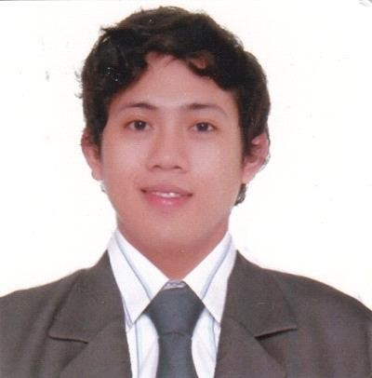
DAN ANDREW T. PARAGOSO
18 Bronze Street, Concepcion 2, Marikina City 1811
Phone: +63 9664050253
Email: danparagoso@gmail.com

CAREER OBJECTIVE
To obtain a position where I can maximize my skills, quality assurance, program development, and to use my ability in the best possible way for achieving the company’s and my goals.

EXPERIENCE

WENPHIL CORPORATION (WENDYS PHILIPPINES)

October 2015 to Present

Roles as Accounts Payables:
- Validate approval, completeness and correctness of invoice details
- Identify required invoice details for countries with specific statutory requirements
- Process invoices/ expenses in the system either by using cost center provided or by matching invoices with appropriate purchase orders receipt.
- Enter scanned link in the Microsoft Dynamics NAV 2017 and updates details in database
- Follow non-standard corrective actions investigate and correct specific line item
- Apply approved credit note or debit note, etc. based on the resolution provided by Supervisor on issues escalated / resolution of aged items.
- Liaise with internal and external clients
- Regularly tabulate data and compile necessary reports
- Disburses petty cash by recording entry; verifying documentation.
- Reconcile vendor statements, research and correct discrepancies
- Pays employees by receiving and verifying expense reports and requests for advances;
Preparing checks.
- Perform day to day management of all payment cycle activities and provide efficient client service
- Assist with month end activities with production of monthly review summary of invoice payments reports.

CORE COMPETENCIES

• Accepted accounting principles
• MS Office Applications
• Good analytical and communication skills
• Policy adherence and awareness
• Strong commitment, vision and integrity.
• Remain calm and work well under demanding conditions.
• Effective at multi-tasking
• Equally effective working independently and in cooperation with others
• Professional and proactive approach to work and has a good eye for details

EDUCATION
BACHELOR OF SCIENCE IN BUSINESS ADMINISTRATION MAJOR IN FINANCIAL MANAGEMENT
Far Eastern University, 2009-2015
Sampaloc Manila, Philippines

PERSONAL INFORMATION
Nationality: Filipino
Birthday: January 09, 1989
Height: 168 cm
Status: Single

*Character Reference available upon request*

