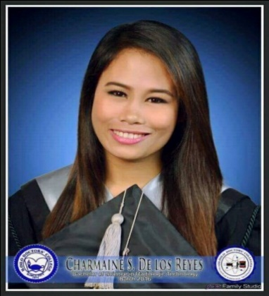

CHARMAINE SALEM DE LOS REYES
Brgy. Botong, Oton, Iloilo 5020 Philippines
Charmaineshyr17@gmail.com
09475451438
OBJECTIVES:

To work in an esteemed institution to be able to utilize my knowledge and skills, and further expand my capabilities by learning new experience.
FUNCTIONAL SUMMARY:
I am very motivated, driven, and professional individual. I am detail oriented and have no problem multi-tasking under pressure, while maintaining a positive and professional attitude.
SKILLS/ QUALIFICATIONS:
• Computerized radiography • Strong Professional Work Ethic
• trauma • Excellent Patient care/ Customer Service
• Special Procedures • Human kindness
• mobile imaging • very resourceful
EDUCATION:
COLLEGE: DOCTORS’ COLLEGE Year Graduated
Timawa, Molo, Iloilo City 2015-2016
Bachelor of Science in Radiologic Technology

EXPERIENCE:
Polymedic Medical Group- Radiologic Technologist (RRT) August 2016-December 2018
• General xray
• Obtain and Process Images
• Double Identify Patients
• Work independently and efficiently
• Maintain safety in divers circumstances
• Maintain accurate paperworks, and provide clear patient documentation
• Respond to stats and call outs in a timely manner
IQOR ILOILO
● Customer Service Representative January 2019 – May 2020
Quiklab Diagnostics, Inc. May 2020 - Present
● Level 1 routine X-ray- Digital Radiography
CERTIFICATION AND LICENCES:
• Registered Radiologic Technologist
• Certificate of Training for Computerized Radiography

