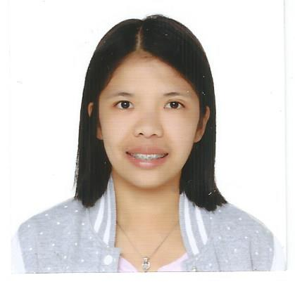
Geraldine B. Gapuz
#043, Purok 27, Upper San Carlos Heights,
Baguio City, Philippines
Contact no: +639202330190/+966 506800302
E-mail Add: gedzgapuz@yahoo.com

OBJECTIVE:
Seeking for an opportunity that may utilize my knowledge and skills for my progress and for the growth of company.

CAREER PROFILE:
· Great sense of responsibility towards the people service and caring.
· Good interpersonal and communication skills.
·Sensitive and responsible enough to provide patient needs.
· Develop good rapport with colleagues and staff.
· Willing to learn and enhance personal skills for self improvement and the company.

PROFESSIONAL EXPERIENCE:

FAHAD AL AJAJI CLINICS, Al Qassim, Buraidah, Saudi Arabia
May 28, 2012 – present
DENTAL NURSE

· Assisted doctor in giving quality care regarding oral health to patients.
· Assisted patient’s needs and concerns.
·Careful sterilizing of dental instruments to ensure sterile conditions.
· Assisting dental care professionals with procedures regarding oral health such as filling of cavities, root canal treatment.
· Preparing new sterilized instruments, materials for every patients.
· Managing clinic and ensuring available stocks to be used for every patients like anesthesia, and other dental materials.
· Taking dental X-ray of patients.
· Giving appointments and directing patients for payments.
· Ensuring proper waste management and disposing of expired dental materials.

BENGUET GENERAL HOSPITAL, La Trinidad, Benguet
June 1 ,2011 – November 30, 2011
STAFF NURSE

· Assessed patient’s condition and status and notify physicians.
· Assisted in doctor’s round of patients.
· Interact with departments regarding patient care.
· Provide health teachings to patient through a ward class.
· Monitored patient’s status and health condition.

STO.NINO HOSPITAL, TUBA, BENGUET
November 1, 2010 – January 31, 2011
JUNIOR STAFF NURSE

· Monitored and maintained patient charts.
· Assessed patient conditions and advised of changes in status.
· Assisted with admittance and discharge of patients.
· Provided quality patient care.

EDUCATION:

UNIVERSITY OF CORDILLERAS
Governor Pack Road, Baguio City Philippines
Bachelor of Science in Nursing 03/2009

SAINT LOUIS HIGH SCHOOL PHILEX
Philex Mines,Padcal,Tuba,Benguet 03/2005

PHILEX MINES HIGH SCHOOL
Philex Mines, Padcal,Tuba,Benguet 03/2001

REFERENCES:

Dr. Mohammed Houssam
Fahad Al Ajaji Clinics
General Dentist
00966556333070
hussam_mohd1971@yahoo.com

Dr. Mohammad Denana
Fahad al Ajaji Clinics
Dental and Oral Surgery Dental Specialist, Medical Director
00966553973353
drdenana@gmail.com

Dra. Reem Nariman
Fahad Al Ajaji Clinics
General Dentist
00966556473332

PERSONAL INFORMATION:
Nickname: Gedz
Birthdate: August 19,1989
Age: 29 y/o
Religion: Roman Catholic
Civil Status: Single

