Renz Aldrin M. Padilla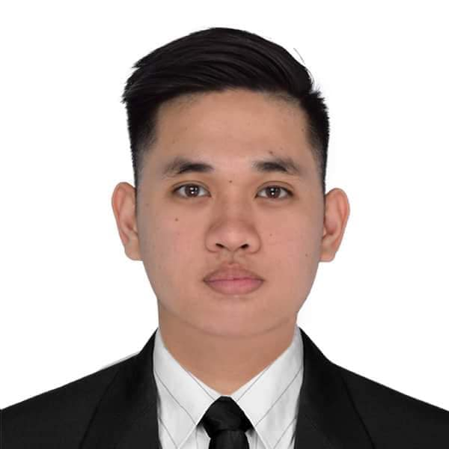
Blk 3 Lot 44, Sto Nino Village Muntinlupa City
Manila, Philippines
renzaldrinpadilla@yahoo.com
+966568071941

CAREER OBJECTIVE
To secure a challenging position that utilizes my years of experience, while allowing me the opportunity to grow professionally.

EDUCATIONAL ATTAINMENT
Tertiary Level: Malayan Colleges Laguna
Bachelor of Science in Hotel Restaurant and Management
A.Y. 2009 – 2014

Secondary Level: Sto. Niño School of Muntinlupa
Sto. Niño School Village, Tunasan, Muntinlupa City
A.Y. 2005 – 2009

Primary Level: Sto. Niño School of Muntinlupa
Sto. Niño School Village, Tunasan, Muntinlupa City
A.Y. 1999 – 2005

PROFESSIONAL EXPERIENCE

July 2019 – Present : Brew 92 (Specialty Coffee Shop)
Jeddah, Saudi Arabia
Specialty Barista

- Preparing Hot and Cold drinks in line with the standards.
- Know how to Calibrate Espresso Machine (SAN REMO/SLAYER) and Grinder
- Learning about brewing method and Beverage Blends
- Learning about variety of Coffee beans that we offer
- Describe menu items to customers or suggest products that might appeal them

August 2016 – February 2019 Wynn Palace hotel
Avenida Da Nave Desportiva, Cotai, Macau
Jr. Bartender
- Interact with customers; take orders for drinks and snacks.
- Serve snacks and drinks to the customer.
- Mix ingredients to prepare cocktails and other drinks.
- Mix drinks, cocktails and other bar beverages as ordered and in compliancewith hotel standard drink recipes.
- Prepare alcohol or non-alcohol beverages.
- Service Wine and Beer to guests.
- Arrange bottles and glasses to make attractive displays.
- Pick up Daily Stocks

July 2014 – June 2016: Gloria Jeans Coffees
SM Supercenter Muntinlupa City, Metro Manila, Philippines
Head Barista
- Preparing Hot and Cold drinks in line with international standards.
- Describe menu items to customers or suggest products that might appeal them
- Know how to Calibrate Espresso Machine (ASTORIA) and Grinder
- Responsible for all cash management during the shift.
- Mentoring and training up new employees.
- Motivating staff to deliver better results
- Responsible for preparing the monthly reports and properly sending it to accounting department.

TRAININGS AND COMPETITION ATTENTED

CERTIFICATIONS/LICENSES
Specialty Coffee Association (Brewing Foundation)
September 2017 - Hong Kong

- Water to coffee ratio basics.
- Introduction to grind size.
- Brew time basics.
- Introduction to water temperature.
5. Introduction to brew turbulence.
6. Basic brewing using equipment including V60 and others.

Specialty Coffee Association (Sensory Foundation)
October 2017 – Hong Kong

- Introducing formal cupping protocol and nez du café.
- Physiology of sensory perception.
- Identifying basic tastes and aromas.
- Understanding cupping protocol

COMPETITIONS/RECOGNITION
- Barista of the Month
December 2019
- 2nd Macau Aeropress Championship (Competitor)
September 2018
- Wynn Palace Barista Competition (Won 1st Place)
August 2018
- 1st Macau Aeropress Championship (Competitor)
August 2017
- 4th Philippine Aeropress Championship (Competitor)
July 2017
- 3rd Philippine Aeropress Championship (Competitor)
March 2016
- 2nd Allegro Latte Art Throwdown (Competitor)
September 2015
- Latte Art Throwdown Pour for Nepal (Competitor)
May 2015

Aeropress Throwdown EDSA BEVERAGE (Won 3rd place)
April 2015
- Latte Art Throwdown, Department of Coffee (Competitor)
April 2015

Gloria Jeans Coffees 1st Latte Art Competition (Won 1st Place)
December 2014

PERSONAL SKILLS AND KNOWLEDGE

- Knowledgeable of Micros Opera System
- Proficient in Microsoft Applications
- Good communication skills
- Speaks basic Cantonese
- Positive attitude towards work.
- Outgoing, Flexible and Highly Motivated
- Self-motivated and can work with minimum supervision
- Possesses the willingness and ability to learn new skills
- Adaptability and ability to work under pressure
- Commended for reliability and trustworthiness

PERSONAL BACKGROUND

Age : 26
Height : 173cm
Weight : 72kg
Date of Birth : October 31, 1992
Place of Birth : Muntinlupa City, Philippines
Civil Status : Single
Citizenship : Filipino

