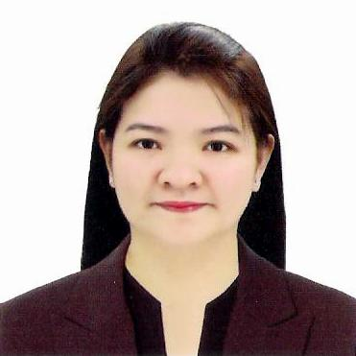
MICHELLE M. MONTEFLOR
175 Gov. A. Pascual St.
Sipac, Navotas City
0939-6196337/02-83512236
miche0105@hotmail.com

PROFESSIONAL SUMMARY
A highly motivated Sales Assistant with over 10-years experience in diverse and challenging airport/retail environment. Ensured that “World Class” Customer Service Standards are implemented and to maximize the sale.
HIGHLIGHTS
- Strong interest in Customer Service, selling and people associated activities
- Excellent communication skills in written and spoken English
- With a basic level of computer literacy
- Effectively manage multiple tasks simultaneously
- Extensive customer service experience and Hermes product training in Paris, France
EXPERIENCE
DUBAI DUTY FREE, DUBAI U.A.E
Hermes Boutique Dedicated Merchandiser – August 2014 to August 2018
- Ensure stock is displayed according to agreed guidelines and standards.
- Request correct stock quantities for maximum sales.
- Receive stock according to agreed standards and procedures.
- Inform all concerned parties regarding stocks out, new products and general product information.
- Set up promotions and availability of items.
- Serve customers for all brands and houses.

Sales Assistant – August 2006 to August 2014
- Adhere to all DDF World Class Customer Service
- Ensure that all merchandises are properly priced and well cleaned at all times
- Monitor movement and stock position of merchandise and advise the supervisor accordingly
- Channel customer requests, complaints, suggestions and comments to supervisors for further action
- Ensure that cash and credit sales are correct
- Ensure that the stocks and matters of importance are endorsed to the incoming shift

TOYOTA CUBAO INC., CUBAO, QUEZON CITY
Customer Relations Officer III
September 2000 – July 2006
- Handles customer’s complaints (receives, analyzes, records, mediates, follow-up and monitors a concern). Involves in the customer concern process from receipt to resolution
- Handles customer contact (inquiry or concerns) directly from the customers through telephone, letter or personal visit. Assists clients on their servicing needs
- Conducts internal Customer Service Training (Customer Service Enhancement Program, Kaizen, Telephone Handling Training and Wok Values and Attitudinal Development)
- Conducts internal surveys (Post Sales and Service Follow-up)
- Channel customer complaints, request, suggestions and comments to all departments for further action
- Prepares monthly report on logged concerns, letters, memo and other related documents
- Participates on kaizen activities (2nd runner up – Kaizen Competition)
- Motivates dealership for its active involvement in the attainment of greater customer satisfaction through customer relation activities

CHINA BANKING CORP
Customer Relation Assistant (New Accounts)
November 1999 – February 2000
- Handles the opening and processing of new accounts
- Accepts SSS, PhilHealth and BIR payments
- Entertains inquiries and assists clients on their banking needs
- Process renewal, termination, interest payment on Trust Account
- Prepares Manager’s and gift checks and update passbook

ON-JOB-TRAINING
INGLENOOK FOODS CORPORATION (NAVOTAS CITY)
Recruitment Assistant
April – May 1998
- Responsible for recruitment, interviews and screening
- Entertain phone inquiries
- Perform any other responsibilities as deemed necessary by the Supervisor

EDUCATION
BACHELOR OF SCIENCE MAJOR IN B.S. PSYCHOLOGY
Colegio de San Juan de Letran
June 1995 – March 1999

PERSONAL DATA
Age : 43 years old
Birthday : 05 January 1978
Civil Status : Married
Citizenship : Filipino
Religion : Roman Catholic

Character references are available upon request.

