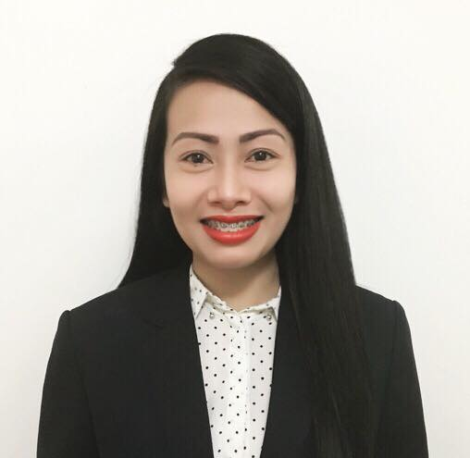

Joann Castro Libatique

Date of Birth
March 14th, 1987

Current Address
Madinat Khalifa South

Contact information
Mobile: +97450782974

Email Address joannlibatique31@gmail.com

Career Objective

A motivated, adaptable and flexible medical graduate, seeking for an employment that will enhance growth and development, to secure a challenging position which allow me to grow professionally, with a challenging role within an ambitious and successful team to build a
long term career, where I can effectively contribute my ideas, knowledge and skills.

Educational Attainment

Bachelor of Science in Nursing, La Union College of Nursing Arts and Sciences, Philippines.

Work Experience

- 2010 – 2011 Call Center Agent, SITEL, Baguio City, Philippines.
- 2011 – 2013 Private Nurse, EMPLOYER, Dubai, United Arab Emirates.
- 2014 – Facility Assistant/Receptionist/Administration at Qatar Foundation, Doha, Qatar.

Skills and Abilities

- Fluent in English and Tagalog, {Oral and Written)
- People and Task Oriented
- Able to find a way to do a job quicker and efficiently over the time
- Ability to communicate with a variety of people from all levels
- Ability to use troubleshooting sense and work through problems and work independently
- Ability to lead and motivate team members effectively
- Ability to work with Microsoft Words/Power Point/ Excel
- Experience in Google Analytics
- Presentation Skills

Extracurricular activities and achievements

- World of welcome training in Hamad General Hospital, Doha, Qatar
- Complaint Handling training in Hamad General Hospital, Doha, Qatar
- Customer Service training in Hamad General Hospital/Qatar Foundation, Doha, Qatar
- Hospitality training in Hamad General Hospital, Doha, Qatar
- World of service training in Hamad General Hospital, Doha, Qatar
- Basic lifer support training in Hamad General Hospital, Doha, Qatar
- Fire and Safety in Hamad General Hospital/Qatar Foundation, Doha, Qatar
- Infection Control in Hamad General Hospital, Doha, Qatar
- Hazardous materials and waste management training in Hamad General Hospital, Doha,Qatar
- Child Protection training in Qatar Foundation, Doha Qatar

Job Profiles and Duties:

- 2010- 2011 Call Center Agent, SITEL, Baguio City, Philippines

- Answer incoming calls and respond to customer’s emails.
- Management and resolve customer complaints.
- Sell products and place customer orders in the computer.
- Provide products and service information to customers.
- Document all call information according to standard operating procedures.
- Follow up customer calls where necessary.
- Up sell products and services.
- Complete call logs and reports.

- 2011- 2013 Private Nurse, EMPLOYER, Dubai, United Arab Emirates.

- Day to day patient interaction.
- Provide personal services, companionship, care and love.
- Monitoring medical status changes of a patient.
- Administration of medications and treatments as pre ordered by physician.
- Monitoring vital signs (changes and alterations documented).
- Diet supervision and monitoring.
- Providing and assisting patient self-care such as bathing, dental care, elimination and other self-care needs.
- Providing various other daily living activities.
- Documentation of patient’s condition and pointing out of significant changes that to be reported to the physician and family.
- Maintain optimum health and wellbeing of the patient.

- 2014 – Present Facility Assistant, Qatar Foundation, Doha, Qatar

- Responsible for providing clerical and administrative support in order to ensure that community engagement services provided an effective and efficient manner.
- Responsible for the registration and payments for all the events, classes, activities, personal booking and facility rental manually and through online (Education City Application).
- Responsible for all communication channels including emails, telephone walk in queries and online support request via EC App.
- Implementing the rules and regulations regarding the usage of the facilities.
- Responsible for reporting and informing the Coordinator in Charge regarding the updates of events, activities and classes.
- Manage customer feedback through the monthly surveys and handle grievances if any accordingly.
- Accept and confirm the facility reservation inquires via email, calls, online reservation (EC App) and walk in if the particular facilities are available for reservation.
- Plan, implement and monitor the progress of action plan events, activities and classes.
- Raising CAFM through internal QF portal for the daily maintenance requirements of the facilities.
- Develop policies and procedures related to operations and implement them based on the management requirement.
- Prepare weekly, monthly and annual reports outcomes and provide recommendation to the management to upswing the faculty and increase footfall and revenues to the facilities.
- Prepare and submit the daily cashier reports and submit them to finance.
- Ensure the safety and security of the facilities and end users with the coordination of the HSSE department.
- Ensure the daily facility check list are submitted accordingly and report the maintenance matter to Facilities Management Department.
- Attend the weekly meeting and keep the MOM accordingly and follow up with the progress.
- EC app monitoring for personal booking, classes, events, rentals and other support requests needed in all recreation facilities and sports classes.
- Creating of timing slots of each facilities/classes, pricing template of each facilities/classes, events tickets for all socials, events and classes via EC App.
- Payment processing through ERP system.
- Assistance needed for the events, classes and activities within the premises.

