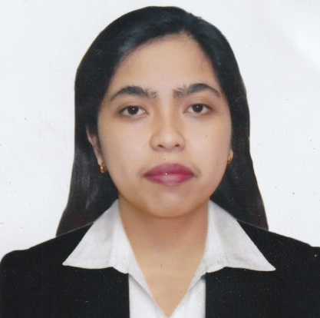

Canarias, Annie M.
Lot 4. No 7, Blk 9, Lebanon St., Brgy Don Bosco Paranaque
09292597239
canariasannie@gmail.com
30 March 1995, 26 years old

Work Experience

October 14, 2014 - July 31, 2019 JOSE RIZAL UNIVERSITY
80 Shaw Blvd., Mandaluyong City Treasury - Cash and Check Disbursement Staff

September 15, 2019 – Current
Top Source Marketing & Distribution Corp.
Manggahan, Pasig
Treasury - Cash and Check Disbursement / Accounting Staff

- Assist customers by providing information and resolving their complaints.
- Reconcile daily remittances versus sales and monthly transactions.
- Compile and maintain non-monetary reports and records.
- Keep periodic balance sheets of amounts and numbers of transactions.
- Monitor daily expenses.
- Monitor all the Request for Payment.
- Handle all bank transactions, business permit and BIR Matters.
- Knowledgeable in Microsoft and Quick books.
- And all other accounting related.

Education

Post-Secondary/
Higher Education: Jose Rizal University
80 Shaw Blvd. Mandaluyong City
Master in Business Administration
2016-2018

Tertiary: Jose Rizal University
80 Shaw Blvd. Mandaluyong City
Bachelor in Business Administration - Major in Accounting
2011-2015

Secondary: Mandaluyong High School
Mandaluyong City
2009 – 2011

Character Reference

Amie Pilande
Student Accounts Supervisor
Jose Rizal University

531-8031 loc 19

Jinky Malbog
Treasury Cash and Check Disbursement Staff
Jose Rizal University
09238049433

Evelyn Sohillo
SUPERVISOR
Top Source Marketing and Distribution Corp.
09651834070

I certify that the above information is true and correct to the best of my knowledge and belief.

Annie Canarias
Applicant’s Signature

