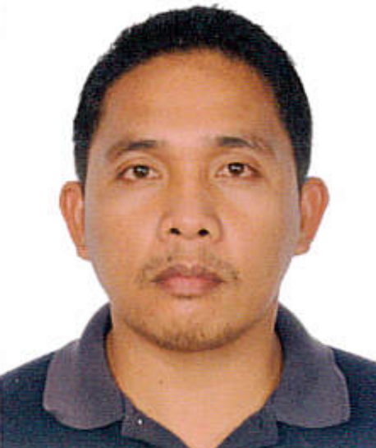
ANDRES B. SALADAN

Current Address : Sitio Guadalupe, Catalunan Grande , Davao City, Philippines , 8000
Mobile No. : +639230845284
Email add : chitoy04@gmail.com

Objective: To apply for any position that fits on my qualification and to be productive and effective to the organization. Will be able to work well as an individual and as a team, with concentration and good physical stamina.

Personal Background :

Gender: Male
Age: 41 yrs. Old
Date of Birth: January 7, 1980
Place of Birth: Bacolod City, Philippines
Citizenship: Filipino
Languages: English, Tagalog and Ilonggo

EXPERIENCE:

Ministry of King Abdulaziz National Guard Health Affairs
Alhassa City, Kingdom of Saudi Arabia
Office of the Deputy Executive Regional Director (DERD) – Runner
March 2015 – March 2018
Job Descriptions:
- Received and deliver messages materials, and information on recipients as instructed.
- Responsible for a prompt delivery and transport of the goods and important documents.
- Plan and followed most efficient routes for delivering goods and important documents.
- Record information, such as items received and delivered and recipients responses to messages.
- Sorted items to be delivered according to delivery route.
- Unload and sort items collected along delivery routes.
- Adhere to patient privacy and confidentiality policy.
- Followed established policies and procedures.
- Perform duties in compliance with Hospital policies and safety standards.
- Performed other job related to duties as required.

Ministry of King Abdulaziz National Guard Health Affairs
Alhassa City, Kingdom of Saudi Arabia

Housing Cleaner Community Assistant
April 2013 – February 2015
Job Descriptions:
- Perform cleaning duties of residential units to maintain them in clean and orderly manner providing excellent standards of cleanliness.
- Wipe and polish residential areas, vacuum and shampoo all carpets, and upholsteries. Remove all pieces of dust, papers and polish all chairs, tables, and shelves.
- Clean picture glasses, polish cabinets, clean and change curtains.
- Sweep and wash /mop well, any floor tiles and marble. Provide air fresheners to rooms available.
- Provide assistance in moving and transporting housing materials.
- Welcomed new arrival residents and assigned as responsible key control assignee, on call duties on locked-out residents.
- Post informative notices to residents with regard to new arrivals, inspection schedules, cleaning schedules, announcements and reminders.
- Identify and notify immediate supervisor concerning need for maintenance and major repairs.

Marina Hotel
Panapaan IV, Rotonda , Bacoor Cavite
Service Room Boy
October 2011 – March 2013
Job Description:
- Ensured that all incoming guest are promptly and properly guided in.
- Ensure that necessary room service such as drinking water or mineral water, drinking glass are served to customers.
- Ensure the cleanliness and readiness of rooms before offering to guest or inform customer if needed rooms are for cleaning or being cleaned.

Marina Hotel
Panapaan IV, Rotonda , Bacoor Cavite
House Keeper
January 2007 – September 2011
Job Description:

- Daily cleaning of rooms and other area of the hotel before the acceptance of the guest.
- Regular inspections of the rooms and take note of the details if needed.
- Daily inspection of the supplies if complete for everyday usage and take note for all the supplies needed.
- Report to Team Leader for any problems arises during duty hours.

Venice Catering Services
12 Maicalum St. Gonzaga Subdivision Brgy. Villamonte , Bacolod City
Kitchen Helper
January 2005 – December 2006
Job Description:
- Properly served food for the guest.
- Responsible in cleaning all the utensils by observing proper hygiene.
- Responsible of maintaining the kitchen area clean and proper.
- Responsible for checking all the supplies in the area.
- Ready for any assigned task from time to time.
Bacolod Convention Plaza Hotel
Magsaysay Avebue, Bacolod City
Waiter
August 2002 – December 2004
Job Description:
- Served food for the guest.
- Responsible in dealing with request from the guest.
- Responsible to check if proper hygiene is applied in serving the food.
- Take note all the beverage needed to be ordered from the supplier.
Bacolod Convention Plaza Hotel
Magsaysay Avebue, Bacolod City
Steward
May 2001 – July 2001
Job Description:
- Responsible for dishwashing all utensils from dining area.
- Responsible for cleaning all pantry area and preparing area for cooking.
- Responsible for collecting all garbage in the kitchen.
- Responsible for checking and refilling gas tank and fuel tanks.

EDUCATIONAL ATTAINMENT:
Animal Production Ruminants NCII
TESDA Wangan National Agriculture School
Davao City, Philippines
October 2020 – Dec 2020
Seafarer Catering / Stewarding Course
Visayan Maritime academy
Bacolod City, Philippines
School Year 2000 – 2001

Automotive Technician
Capitol Institute of Technicians
Bacolod City, Philippines
School Year 1997

Saint Joseph Academy
E.B Magalona Negros Occidental , Philippines
School Year 1993 – 1997
Secondary education

Special skills : Cooking , Basic Bartending , Catering

Character Reference:
Ali Al Qarni
Deputy Executive Regional Director of Medical Services
Ministry King Abdulaziz of National Guard Health Affairs Hospital
Al Hassa , Kingdom of Saudi Arabia
Work: +966 3 5910000 Ext. 35518

Saud Ibnshamsah
Director Housing Service
Ministry King Abdulaziz of National Guard Health Affairs Hospital
Al Hassa , Kingdom of Saudi Arabia
Work: +966 3 5910000 Ext. 36780

Sana Al-Monem
Coordinator Housing Service
Ministry King Abdulaziz of National Guard Health Affairs Hospital
Al Hassa , Kingdom of Saudi Arabia
Work: +966 3 5910000 Ext. 36792

I certify that the above information are true and correct to the best of my knowledge and abilities.

ANDRES BOTEROS SALADAN

