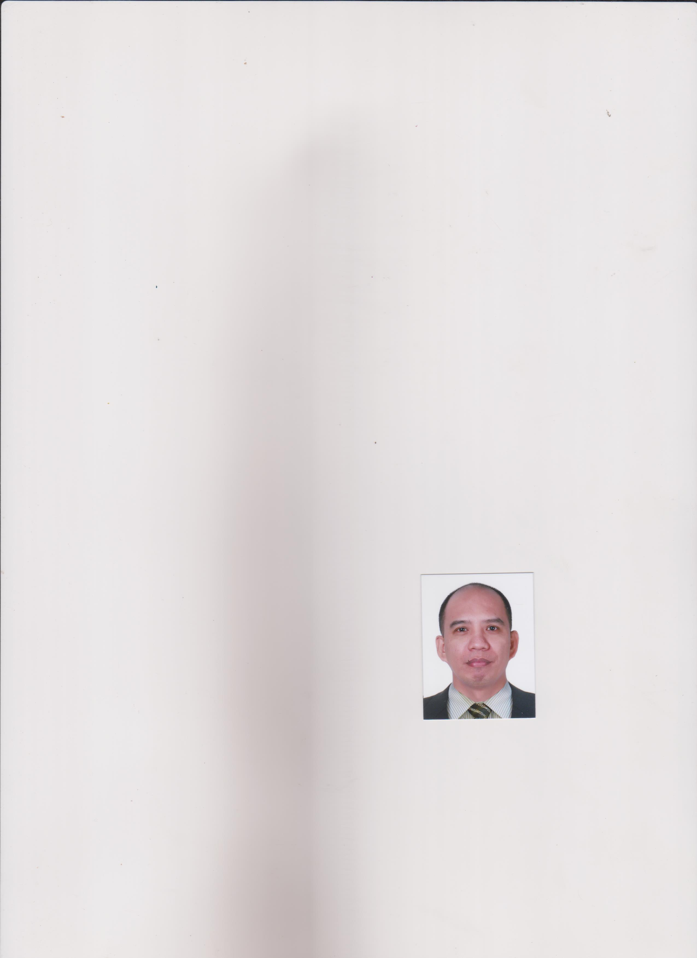
RONILO Larriba BURLAT
B7 L9 Aces code Project 1
Brgy. Ugong, Valenzuela city, Metro Manila
Contact Nos. 09052757113/ 216-2792
Email Add: ronmiggy0530@gmail.com

CAREER OVERVIEW
Committed and motivated administratively with exceptional service and decision making skills, strong work ethic, professional demeanor, great initiative, high performing remarks with extensive experience working with a diverse client base and delivering results.

PROFESSIONAL EXPERIENCE

SECTION SUPERVISOR July 30, 2018- January 22,2021
PUREGOLD Price Club Inc. Carriedo, Sta. Cruz, Manila
- Managing workflow on various deliveries and stocking
- Monitor and conduct LIFO and FIFO on stocks at warehouse.
- Ensure quality on deliveries pertaining to Perishables and Dry Goods
- Creating and Managing time schedule and employees performance

ADMINISTRATIVE ASSISTANT August 5, 2016-March 10, 2017
Metrogate Dasmarinas Estate HOA Inc. Metrogate Estate Sampaloc 1
Dasmarinas, Cavite
- Answer and direct phone calls, handle administrative requests and queries from senior Administrator, Officers; Organizing and scheduling appointments with admin software and Planning meetings and taking detailed minutes
- Providing support to Admin, officers and employees, assisting in daily office needs and managing our company’s general administrative activities.
- Generation of Statement of Accounts for Lot owner and Home owners for Monthly dues and other fees, Issuance of Permit and licenses for newly acquired lot for construction including construction ID’s, schedule and Taxes schedule, report and compliance, payroll and bills due for payment
- Write and distribute email, correspondence memos, letters, faxes and forms, Assist in the preparation of regularly scheduled reports, Develop and maintain a filing system and Update and maintain office policies and procedures

ADMINISTRATIVE OFFICER July 12, 2013- January 31, 2016
POLYTECH Training @ Assessment Center Inc. (TESDA-TVET) Imus, Cavite
- Monitored project schedules for Scholarship project at a time
- Oversaw the development and launch of New Training Programs and Regulation Assessment
- Recruited, hired and trained at least twenty-five (25) trainees per scholarship programs endorsed by the TESDA bureau
- Boosted company efficiency through technology upgrades and process improvements such as Tools and Equipment
- Built and maintained effective accounting receivable and cash flow monitoring system
- Maintain administrative documents, files, correspondence, letters and memo.

BOOKKEEPER January 5, 2011- June 20, 2013
KOTSEHAN Automall Corporation Imus-Cavite
- Issued paycheck to vendor and suppliers on a bi-weekly basis
- BIR Concern on monthly and annual Taxes report and submission on time electronically
- Updated confidential employee banking information with accuracy and speed
- Maintained accounts receivable documentation electronically and on paper
- Handled cash and deposits using the proper accounting procedures and documentation
- Entered weekly sales and customer count sheets for review by management
- Process payroll electronic deposits and employees pay adjustments
- Maintaining book of accounts and BIR reports/ compliance

ADMINISTRATIVE ASSISTANT May 2010- November 2010
CORREOS Movement International Inc. Dasmarinas, Cavite
- Drafted meeting agendas, supplied advance materials and executed follow-up for meetings and team conference
- Managed the receptionist area, including greeting visitors and responding to telephone and in person requests for information
- Designed electronic file systems and maintained electronic and paper files
- Wrote reports and correspondence from dictation and handwritten notes
- Made copies, sent faxes and handled all incoming and outgoing correspondence
- Created and maintained spreadsheets using advanced Excel Functions and calculation to develop reports and lists.

EDUCATION
BACHELOR OF SCIENCE IN COMMERCE – BANKING & FINANCE Year 2001-2002
Saint Michael’s College- SPC Cantilan, Surigao del Sur

TESDA PROGRAM
BREAD & PASTRY PRODUCTION NC II Year 2015
COMMERCIAL COOKING NC II Year 2013
National Certificates NC II Imus, Cavite

PERSONAL INFORMATION

- Place of Birth: Bislig City, Surigao del Sur
- Date of Birth: January 24, 1981
- Sex: Male
- Status: Single
- Hobbies: Net Surfing for new ideas and interest, Cooking, Reading and Travel

SKILLS
- Communication, ability to work under pressure, time management , Leadership, Speed typist and has a strong knowledge of office and administrative software including Microsoft Excel, Word and Power Point Presentation

TRAINING AND CERTIFICATION

- ^{3nd} TESDA CALABARZON TVET CONGRESS September 29, 2015
Club Manila East, Taytay Rizal, Metro Manila

- 1st TESDA CALABARZON TVET YOUTH CONGRESS May 26, 2015
Batangas Convention Center, Batangas City

CHARACTER REFERENCES

ALEJANDRO AMPARO JR.
Credit Analyst
BPI-BANCO
Surigao City
0933-8539750

DEXTER YU
Store Operations Manager
Puregold Price Club Inc.
Carriedo, Sta. Cruz, Manila
0905-6699000
MR. KENNETH V. LOMBOS
UTPRAS FOCAL
TESDA Provincial Office
Trece Martires, Cavite
0922-5196540

