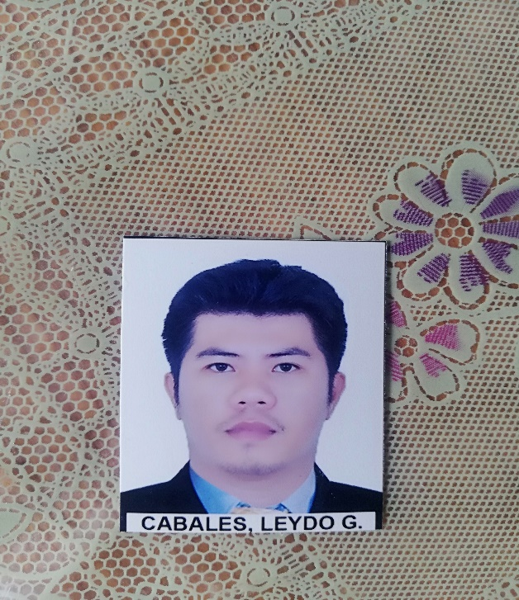

Leydo G. Cabales

Purok Fatima, YCF Village Brgy. San Antonio, Agdao, DavaoCity
Contact Number:09489726679
Email: reiodyel@gmail.com

______________________________________________________________________________
OBJECTIVE:
- To obtain position in the construction industry with upward mobility from apprentice to welder
- To obtain welding position in a stable company that will allow me to fully utilize my skill and also to a real asset to my employer
- To obtain a position in or related to the field of welding in special interest in securing a position with a solid company that can utilize my welding skill

RELATED EXPERIENCE:

► June 2018-up to present. POSITION: Welder Fabricator
Informal contractors group

► December 2013-October 2017 POSITION: Welder Fabricator
Kabushikigaisha Iwasaki
Yodogawa ku-Kashima Osaka Japan

► May 2009-March2013 POSITION: Welder Fabricator
In different Welding Companies in
EPZA Cavite, Philippines

WELDING SKILL:
- Proficient in the use of welding equipment
- Keeping work station in a clean and safe condition
- Cutting work pieces using automatic cutting and oxy acetylene cutting
- Able to SMAW weld in thickness from 5.0mm to unlimited
- Having a high level of understanding of HSE working practices, procedure and their implementation
- Being able to endure noise, fumes, and dust
- Igniting torches and adjusting valves, amperage, or voltage to get desired flames
- Always working in an accordance with established safety procedure
- Accurately following instruction

SPECIAL SKILLS AND SPECIALIZATION:
- Welding techniques - GMAW Welding
- Computer literate - GTAW Welding
- Spot welding - FCAW Welding
- Cutting and Joining Materials - SMAW Welding
- Safe Working Practice - Cutting and joining materials
- Conducting Inspections - Time keeping
- Clean finishing - Coordination
- Computer literate - Professional and responsible
- Working unsupervised - Mature attitude
- Maintaining accuracy

EDUCATION:

► Bislig City Livelihood And Skill Training Center ► Naic Elementary School
Bislig City Surigao del Sur Naic, Cavite
Basic SMAW welding Primary
December 2008 March 2005

► San Isidro National High School
San Isidro Bislig City Surigao del sur
Secondary
March 2008

Seminar and Training Attended:

► FILJAP Skill And Training Center
Espanya-Sampaloc, Manila
- SMAW NC 2 AND QWT
- GMAW NC 2 AND WQT
- GTAW NC 2 AND WQT
- FCAW NC 2 AND WQT

PERSONAL INFORMATION:

Date of birth: February 19 1989
Age: 32
Civil status: Single
Citizenship: Filipino
Sex: Male
Height: 164cm/5”4
Weight: 69klos
Religion: Christian

REFERENCES:

Edgardo C. Amogues
Civil engineer

Reynaldo c. Villanueva
Businessman

I hereby certify that above information is true and correct to the best of my knowledge.

Leydo G. Cabales
Applicant

